Indian philosophy refers to philosophical traditions of the Indian subcontinent. A traditional classification divides orthodox (āstika) and heterodox (nāstika) schools of philosophy, depending on one of three alternate criteria: whether it believes the Vedas as a valid source of knowledge.

There are six major schools of orthodox (astika) Indian Hindu philosophy—Nyaya, Vaisheshika, Samkhya, Yoga, Mīmāṃsā and Vedanta, and five major heterodox (nastika) schools—Jain, Buddhist, Ajivika, Ajñana, and Charvaka.

Many Hindu intellectual traditions were classified during the medieval period of Brahmanic-Sanskritic scholasticism into a standard list of six orthodox (Astika) schools (darshanas), the "Six Philosophies", all of which accept the testimony of the Vedas.
- Samkhya, the rationalism school with dualism and atheistic themes
- Yoga, a school similar to Samkhya but accepts personally defined theistic themes
- Nyaya, the realism school emphasizing analytics and logic
- Vaisheshika, the naturalism school with atomistic themes and related to the Nyaya school
- Purva Mimamsa (or simply Mimamsa), the ritualism school with Vedic exegesis and philology emphasis, and
- Vedanta (also called Uttara Mimamsa), the Upanishadic tradition, with many sub-schools ranging from dualism to nondualism.
These are often coupled into three groups for both historical and conceptual reasons: Nyaya-Vaishesika, Samkhya-Yoga, and Mimamsa-Vedanta.
The Vedanta school is further divided into six sub-schools: Advaita (monism/nondualism), also includes the concept of Ajativada, Visishtadvaita (monism of the qualified whole), Dvaita (dualism), Dvaitadvaita (dualism-nondualism), Suddhadvaita, and Achintya Bheda Abheda schools.

Several Śramaṇic movements have existed before the 6th century BCE, and these influenced both the āstika and nāstika traditions of Indian philosophy.
The Śramaṇa movement gave rise to diverse range of heterodox beliefs, ranging from accepting or denying the concept of soul, atomism, antinomian ethics, materialism, atheism, agnosticism, fatalism to free will, idealization of extreme asceticism to that of family life, strict ahimsa (non-violence) and vegetarianism to permissibility of violence and meat-eating. Notable philosophies that arose from Śramaṇic movement were Jainism, early Buddhism, Charvaka, Ajñana and Ājīvika.

Pramāṇa literally means "proof" and is also a concept and field of Indian philosophy. Hinduism identifies six pramanas as correct means of accurate knowledge and to truths: Pratyakṣa (perception), Anumāṇa (inference), Upamāṇa (comparison and analogy), Arthāpatti (postulation, derivation from circumstances), Anupalabdhi (non-perception, negative/cognitive proof) and Śabda (word, testimony of past or present reliable experts)

The Self in Indian Philosophy
Classical Indian philosophy consists of three leading schools. The ancient Brahminical Hindu views from the Vedas form the foundation of Indian thought. The later Buddhist school of thought started a new tradition that spread around Asia and the world. The third school represents the not so well-known materialists of the Charvaka tradition.
The Brahminical or orthodox (astika) schools of Indian philosophy argues that the self or Atman is a substantial but non-material entity. The Katha and Chandogya Upanishads, for example, define the Brahminical conception of the self as:
The light of the Atman, the spirit is invisible, concealed in all beings. It is seen by the seers of the subtle when their vision is keen and bright … The Atman is beyond sound and form, without touch and taste and perfume. It is eternal, unchangeable, and without beginning or end: indeed above reasoning. An invisible and subtle essence is the spirit of the whole universe. That is Reality. That is Truth. THOU ART THAT.

The Brahminical view on the nature of the self as portrayed in the Upanishads supports four central theses:
- The self exists.
- The self is immortal and without beginning or end.
- The self is essentially non-material.
- The self is identical with Brahman, the highest reality.

The heterodox (nastika) schools in Indian philosophy, such as the Charvaka materialists and the Buddhists, question the Brahminical arguments for a substantial, persistent and non-material self on metaphysical, moral and political grounds. The Buddhists and the Charvaka oppose the Hindu caste system. They believe that the Vedas are full of falsehoods, self-contradictions and tautologies.

Existence of the Self-
SĀnkhya and Yoga-The concepts of the self in the Sānkhya and the Yoga schools are also sufficiently similar to be treated together. In Sānkhya the self is called purusa or soul and represents pure consciousness, in opposition to prakti, which represents matter. The self loses its inherent consciousness by mistakenly identifying itself with the body as involved in the process of sasāra; the self is utterly passive and merely a spectator but mistakes itself for an actor and thus undergoes the ups and downs of the cosmic drama. Although the word purusa is often used in the singular, in reality the system allows for a plurality of puruas, all consisting of pure consciousness, but distinct from each other and prakti or matter. The purusa in Sākhya and Yoga is an uncaused, eternal, all-pervading, and changeless reality, which witnesses change as a transcendent subject distinguished by pure consciousness that can itself never become an object of knowledge. Salvation consists of this discrimination (viveka ) that one is pure spirit and not the mind with whose derivative reality one identifies oneself. The system of Yoga with its eight limbs or constituent elements is meant to guide one, through a series of meditations, to the realization of this ultimate transcendent witnessing subject as distinct from the mind, body, and ego just as the surface of the mirror is totally independent of the objects that are reflected in it but appear included in it.

2. The Nyaya-Vaisesika- The concepts of the self in the Nyāya and the Vaiśeika schools have much in common and hence are presented together. According to the Nyāya and the Vaiśeika school, the soul or ātman is eternal, but consciousness is not its inherent property. Consciousness arises when the self or ātman is conjoined with manas or the mind, which is, however, by itself inert. The soul or ātman differs from other atomic or all-pervasive objects in that, unlike them, it is potentially capable of consciousness. The selves are numerous and all-pervading but remain distinct in the state of release because of the property of viśea, which accounts for things being different that are in other respects all alike—for example, two atoms that are otherwise identical are not numerically one. The self has no consciousness in the state of release because such a state involves the absence of manas. The ātman in Nyāya is a unique substance that possesses the attributes of cognition, emotion, and
3. MĪmĀsĀ-The concept of the self in Mīmāsā is broadly similar to that found in Nyāya and Vaiśeika, but there are some differences. The list of specific qualities characterizing the self is similar but not identical, with Mīmāsā dropping those of dharma and adharma and adding that of śakti or potency. The most significant difference however consists of the fact that while according to the Nyāya-Vaiśeika school knowledge is a quality of the self, according to Mīmāsā it is an activity of the self.
VedĀnta
The conception of the self or ātman in Vedānta needs to be presented in accordance with the school of Vedānta involved—whether it is Advaita Vedānta, Viśiādvaita Vedānta, or Dvaita Vedānta. Thus the exact conception of the ātman depends on whether we are dealing with the "non-dualism of the qualified" (Advaita) or dualism (Dvaita). Prior to identifying the self in these three schools of Vedānta, however, it might be useful to indicate the concept of the jīva they all share in common on the basis of their reliance on the same foundational texts. Another aspect of the issues relating to the self or ātman, which receives relatively greater treatment in Vedānta than in other systems, is its relationship to Brahman, or the ultimate reality.

CĀrvĀka- According to the Cārvāka school, the body itself constitutes the self (deha eva ātmā ); of course, what is meant is that the conscious body constitutes the self. However, this immaterial element of consciousness in the body is considered an epiphenomenon of the material components of the body, in a manner reminiscent of scientific materialism. The Cārvāka school would establish the plausibility of the emergence of a property not contained in the elements by their coming together on the analogy of water, which possesses the quality of wetness, a property not possessed by the two gases of which it is composed. There is no question then of postmortem survival according to this school, as consciousness perishes with death. It therefore emphasizes making the most of life, with a pleasant death serving as the counterpart of salvation. Thomas McEvilley (2002) notes that these doctrines are similar to the ones Plato attributes to the physiologoi.
Jaina- According to the Jaina school, the self consists of the soul or jīva which occupies the body. The soul is formless but it can occupy a body just as light might occupy a room. It is a striking feature of the Jaina view of the self that this jīva is said to be coextensive with the body. In view of the fact that the soul occupies the body, it can be said to occupy space, as the body does, and may even be said to be capable of extension, as when the body grows. The whole range of existence, including plants and minerals along with insects and so on, possesses a conscious soul, and if such consciousness—which is characteristic of the soul—is not apparent, it is because it is dormant under the influence of karma. In Jainism karma is considered a very fine material substance that can permeate a soul, just as motes of dust might permeate light. Jaina soteriology consists of ridding the jīva of such matter, which keeps it weighed down in sasāra, so that, freed from it, it can rise to the top of the "universe" and be free forever. According to Jainism, knowledge is the natural attribute of the ātman, which is kept in check by ajīva or inanimate components of our being. "The eyes, for example are viewed here not as an aid to seeing, but as a check in the absolute sight of the soul" (Hiriyanna 1949, p. 61).

Bauddha-While the Cārvāka school does not believe in an ātman and denies anything like liberation, and the Jaina school believes in both, Buddhism denies the existence of a self or ātman while upholding liberation from rebirth in the usual Indic sense. According to Buddhism, continuity is possible without identity; hence there is no need to postulate a self that is reborn, for the next birth can be viewed as being caused by the present in the process of coming to an end, like an echo. Nirvāṇa brings silence to the re-echoing chamber of sasāra. The Buddhists seem to create many apparent logical difficulties for themselves by denying a permanent self or ātman but according to them the other systems create their own existential problems by believing in one. The Buddhist critique of a substantial ontology is very thoroughgoing; according to this critique, nothing whatsoever in this world possesses a permanent substratum (sabbe dhammā anattā ). The permanence or lack of it in the self has been a major issue in the Hindu-Buddhist interface (Chakrabarti 1999, chapter 5, appendix).

Nyaya School
The Nyāya School is founded by the sage Gotama (who is not confused as Gautama Buddha). He is familiarized as ‘Aksapāda’. Nyāya means correct thinking with proper arguments and valid reasoning. Thus, Nyāya philosophy is known as tarkashāstra (the science of reasoning); pramānashāstra (the science of logic and epistemology); hetuvidyā (the science of causes); vādavidyā (the science of debate); and anviksiki (the science of critical study). The Nyāya philosophy as a practitioner and believer of realism seeks for acquiring knowledge of reality.

Nyāya school of thought is adhered to atomistic pluralism and logical realism.
It is atomistic pluralism on the account that atom is the constituent of matter and there are not one but many entities, both material and spiritual, as ultimate constituents of the universe. By holding pluralism standpoint it refutes materialistic and spiritualistic monism.

It is a system of logical realism by 2 dint of its adaptation the doctrine that the world exists independently from our perceptions and knowledge. Further, the independent existence of the world can be defended not by our faith or intuition but by the logical arguments and critical reflection on the nature of experience.

SIXTEEN DIVISIONS ( PADARTHAS ) OF REALITY-
Nyaya divides perceivable and imperceivable reality into sixteen divisions ( padarthas ) that are -
- Pramana, the sources of knowledge – Praytaksha ( Perception), Anumana (Inference), Comparison (Upamana), Sabda (verbal testimony)
- Prameya , the object of knowledge (Atma - the individual conscious, Sarira - the material, Indriyas - the sense organs, Artha - the objects of the senses, Buddhi – cognition, Manas - the mind, Pravrti – activity, Dosa - mental defects, Pretyabhava - life and death, Phala - the results of pleasure and pain, Duhkha – suffering, Apavarga - permanent relief from all suffering
- Samsaya , doubt or the state of uncertainty
- Prayojana , the aim
- Drstanta , example
- Siddhanta , doctrine
- Ayayava , the constituents of inference
- Tarka , hypothetical argument
- Nirnaya , conclusion
- Badha , discussion
- Jalpa , wrangling
- Vitanda , irrational argument
- Hetvabhasa ,specious reasoning
- Chala , unfair reply
- Jati , generality based on a false analogy
Interpreting the term ‘knowledge’ Nyāyikas says that it may be treated as cognition, assumption, consciousness, or manifestation of objects.
Knowledge is of subjective and objective. Subjective knowledge differs from objective knowledge. If different people give the different opinion on a particular object or a fact then the knowledge about that object will be treated as subjective knowledge. For example, on a road accident if we ask different people who were present there, we will find different opinions from them. Hence, the view on the accident is treated as subjective knowledge.
On the other hand, if most of the people express their views on an object similar to others then the knowledge of that object would be treated as objective knowledge. For example, all people agreed that apple is a fruit and eatable. Thus, any sort of knowledge is a revelation or manifestation of objects. Just as a tube light manifests physical things of a room, likewise, knowledge reveals all objects surrounded it.
The Nyāya Philosophy is being the upholder of realism expresses that knowledge is always dealt with object. Knowledge may be valid or invalid. Valid knowledge is called pramā and invalid knowledge is called apramā. The Nyāya School advocates that valid knowledge is the true and right apprehension of an object. It is the manifestation of an object as it is. The characterization of valid knowledge is a consequence of the correspondence theory of truth which states that truth is the correspondence between a proposition and reality. Thus, valid knowledge is treated as presentative knowledge. Presentative knowledge arises when the object of knowledge is directly present to the knower. For example, Dr. Biplab perceives a pen in his shirt pocket is an instance of presentative knowledge. Valid knowledge is produced by the four valid sources of knowledge -perception, inference comparison, and sabda.
Invalid knowledge is defined as the wrong apprehension of object. It includes memory (smṛuti), doubt (samsaya), error (viparyāya), and hypothetical reasoning (tarka). Memory is not presentative but representative knowledge.

Self and Liberation
Nyāya thinkers are realists. According to them, there are real things out in the world that correspond to our perceptions of them. Their existence is independent of our knowing them. Not only are the objects of our experience independent of our thoughts and knowledge of them, but they are also independent of each other. The Nyāya subscribe to a pluralism of sorts. The universe in this view is composed of nine substances called dravyas. Mind and self are among the nine.

The Nyāyikas expressed that there are infinite number of individual self exists in the universe. All those have perceivable qualities like pleasure, pain, etc. They are eternal and all pervading.
The self (ātman) is nonmaterial and eternal. The self, however, is not an object of direct perception. Its existence is known inferentially. According to Nyāya thinkers, the self, mind, and consciousness are different. The self and the mind are substances, but consciousness is a quality which inheres in the self. The mind by itself does not possess the quality of consciousness. Consciousness is not the self but only an attribute of the self. It is an accidental attribute of the self. The self in its original state has no consciousness and hence devoid of cognition and knowledge. But when it comes to contact with sense organs it acquires consciousness.

Self is regarded as ‘I’ the knower and it is known through internal perception. Since there is self, there is bondage and hence, aspires for liberation or salvation. Liberation is the state refrain from all kinds of sufferings and bondage those arises because of the self’s association with body and sense organs. Nyāyikas uphold association and attachment are the sources of pain and suffering. Hence, as long as self is attached with body and sense organs, it goes through the cycles of birth and death. This implies Nyāyikas believe in law of karma. Liberation, according to Nyāya, can be achieved when there is cessation of karmic chain or karmic influx. It is a state where self is detached from body and sense organs.

Sāmkhya-

- Samkhya is one of the six āstika schools of Hindu philosophy. Sāmkhya Darshana is considered to be most ancient of all the Hindu philosophies. It is most related to the Yoga school of Hinduism, and it was influential on other schools of Indian philosophy.It forms the theoretical foundation of Yoga.
- Samkhya’s epistemology accepts three of six pramanas ('proofs') as the only reliable means of gaining knowledge. These include pratyakṣa ('perception'), anumāṇa ('inference') and śabda (āptavacana, meaning, 'word/testimony of reliable sources').
- The Proponent of Sankya (Also written as Samkhya) Philosophy was Rishi (Saint) named Kapil, who composed a text called ‘Samkhyasutra’.
- Samkhya is strongly dualistic. Samkhya philosophy regards the universe as consisting of two independent realities: puruṣa ('consciousness') and prakṛti ('matter'). These two realities exist parallel without affecting each other. Jiva ('a living being') is that state in which purusha is bonded to prakriti in some form.
- According to Sankhya Philosophy the evolution of universe is due to interaction between ‘Prakriti’ (Primordial form of Nature) and ‘Purusha’ (Pure Consciousness, Cosmic Consciousness, Soul) and their interaction further creates 23 more elements in this process of evolution. The cause assumed behind this process of expansion is ignorance (avidya), which according to Kapila is the lack of the ability to discriminate (Vivek-khayti) between real (sat) and unreal (asat).This situation resulting out of indiscrimination is caused by Vritties (tendencies) or restlessness of mind. The Soul (Purusha) gets itself discriminated from various gross and subtle forms of Prakriti by acquiring wisdom (discriminatory power) through practicing a rigorous Yogic path and as a result, it is no more subjected to the limitations posed by the Prakriti. After realizing himself as a distinct identity Purusha is no more subjected to worldly sufferings.

Purusha & Prakriti –

Prakriti or Prakruti (from Sanskrit language प्रकृति, prakṛiti), means "nature". Prakriti refers to "the material world, nature, matter, physical and psychological character, constitution, temper, disposition". In Samkhya-Yoga texts, Prakriti is the potency that brings about evolution and change in the empirical universe. It is described in Bhagavad Gita as the "primal motive force". It is the essential constituent of the universe and is at the basis of all the activity of the creation. According to Samkhya and the Bhagavad Gita Prakrti or Nature is composed of the three gunas which are tendencies or modes of operation, known as Rajas (creation), Sattva (preservation), and tamas (destruction). Prakriti is the state of equilibrium of sattva, rajas and Tamas, which are substances and constitute prakriti. They are in a state of equipoise which is not inactivity but a kind of tension.

GUNAS -
- Sattva is the quality of balance, harmony, goodness, purity, holism, alleviating, luminous and enlightening, construction, creativity, positivity, peacefulness, and virtue.
- Rajas is the quality of passion, activity, self-centeredness, egoism, individualization, drivenness, movement, exciting, volatile, restles urgent. and dynamism.[
- Tamas is the quality of imbalance, disorder, chaos, anxiety, impurity, destruction, delusion, negativity, dullness or inactivity, apathy, inertia or lethargy, violence, viciousness, and ignorance.
As the gunas churn together, the manifest world of Prakriti evolves out of the primordial matrix.
The gunas coexist, partnering together to produce our experience of reality. By union of contrasts, these attributes operate by blending and transforming, like water, modifying our perceptions according to the predominance of one or the other. Everyone and everything in manifest reality is made up of all three gunas in various combinations and permutations. In Indian philosophy, these qualities are not considered as present in either-or fashion. Rather, everyone and everything has all three, only in different proportions and in different contexts. The living being or substance is viewed as the net result of the joint effect of these three qualities. According to Samkya school, no one and nothing is either purely Sattvik or purely Rajasik or purely Tamasik. One's nature and behavior constitute a complex interplay of all of all three gunas, in varying degrees. In some, the conduct is Rajasik with significant influence of Sattvik guna; in some it is Rajasik with significant influence of Tamasik guna, and so on.

When rajas dominates, the mind is incredibly active. There is a lot of movement, a restlessness that can be energetic and creative but also leads to attachment to the outcomes of those endeavors. When tamas dominates there is darkness. The mind is first and foremost sleepy and delusion, disinterest, lethargy, and inertia manifest. Most importantly, the mind remains spiritually ignorant of the truth of the nature of reality.But when sattva dominates, there is an abundance of goodness and the mind is clear. Sattva, which translates as essence or beingness, is the principle of light and insight. Happiness and peace manifest.

In Indian mythology, Vishnu is envisioned with more Sattva, Brahma with more Rajas, and Shiva seen with all three Gunas

Purusha (Cosmic Consciousness) is that which is unchanging (aksara) and is uncaused. Puruṣa. Puruṣa is the transcendental self or pure consciousness. It is absolute, independent, free, imperceptible, unknowable through other agencies, above any experience by mind or senses and beyond any words or explanations. It remains pure, "nonattributive consciousness". Puruṣa is neither produced nor does it produce. It is held that unlike Advaita Vedanta and like Purva-Mīmāṃsā, Samkhya believes in plurality of the puruṣas.

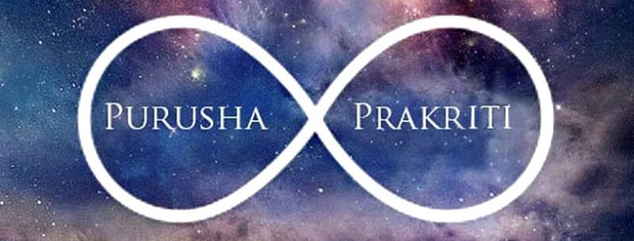

THEORY OF EVOLUTION ACCORDING TO SANKHYA

According to Sankhya, nature is a blind force which is self-operating like a machine. All the causes and effects lie hidden in it. So it does not create anything new but brings out what is already present in it as a fixed program. Nature (prakriti) is both cause and effect. It is not created but creates. It is permanent but changeable. Things evolve in nature at the most basic and structural level with the elementary units called tattvas. Nature comes into action when it meets the purusha or individual soul. The changes in prakriti begins as it comes in contact with purusha. Their meeting causes the prakriti to become active and start evolving.
The creation or evolution of the world begins with the samyoga or effective contact of purusha(consciousness) and prakriti(matter).the totality of the karmas of the purushas disturbs the balance of gunas in prakriti and starts the process of evolution. So the first development with in nature upon contact with purusha is disbalance in the three qualities or gunas namely sattva(purity, dispassion and light),rajas(activity, passion and intensity)and tamas(inactivity, ignorance and darkness). As a result of the gunas mixing with one another, the first product of evolution of prakriti is mahat or buddhi( the cosmic intellect). It is the natural function of buddhi to manifest itself and other things. Buddhi is different from purusha or the self which goes beyond all physical things and qualities. But it is the base of all intellectual processes in all individual beings. After that the second product that arises directly out of mahat is called ahankara (cosmic ego, the principle of individuation). The function of ahankara is the feeling of “I and mine” (abhimana) it is because of ahankara that the self considers itself wrongly indeed to be an agent or a cause of action. A desirer of and striver for end and a feeling of ownership. There are three kinds of ahankara according to the predominance of one or the other three gunas.
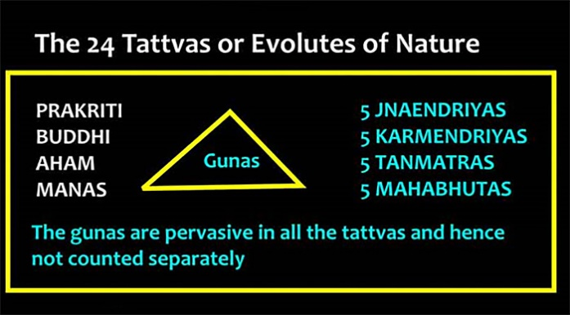
The first one is called vaikarika or sattvika when the element of sattva predominates in it, second one is called taijasa or rajasa when the element of rajas predominates and the third one is called bhutadi or tamasa when the tamas element predominates. The sattva ahankara gives rise to the eleven organs, namely the five organs of perception (jnanendriya), the five organs of action (karmendriya), and the mind (manas). The tamasa ahankara gives rise to five subtle elements of earth, water, fire, air and ether (tanmatras). They further evolve into the five mahabhutas or gross elements (of earth, water, fire, air and ether). The rajas ahankara is involved in both the sattvika and tamasa ahankara, and supplies the energy needed for the change of sattva and tamas into their products.
In all, including the prakriti , there will now be 24 cosmic principles or elements. The rest of creation takes place by their permutation and combination, each purusha getting involved with a psycho-physical complex(body)according to his deeds (karma). There are two stages of evolution namely the psychical and the physical. The history of the evolved universe is a play of twenty four principles, of which prakriti is the first, the five gross elements are the last, and the thirteen organs(karanas)and five tanmatras are the intermediate ones.
To ease the analysis, Sāmkhya divided the twenty five principles into four categories;
(1) Neither evolute nor evolvent, that which is neither produced nor produces. In this category comes Purusa. One can understood Purusa as the Cosmic Spirit or Cosmic consciousness.
(2) Not evolute but evolvent, that which is not produced but produces. In this category falles Prakrti. Prakrti can be understood as Cosmic energy or Cosmic substance or the primordial substance.
(3) Evolute and evolvent, that which is produced and which produces. In this category come Mahat (Cosmic intelligence), Ahamkara (Individuating principle) and five Tanmatras (subtle elements).
(4) Evolute but not evolvent, that which is produced but do not produce. Manas (Mind), five Jñānendriyas (Abstract knowledge senses), five Karmendriyas (Abstract Working senses), and five Mahabhutas (gross elements) fall in this category.

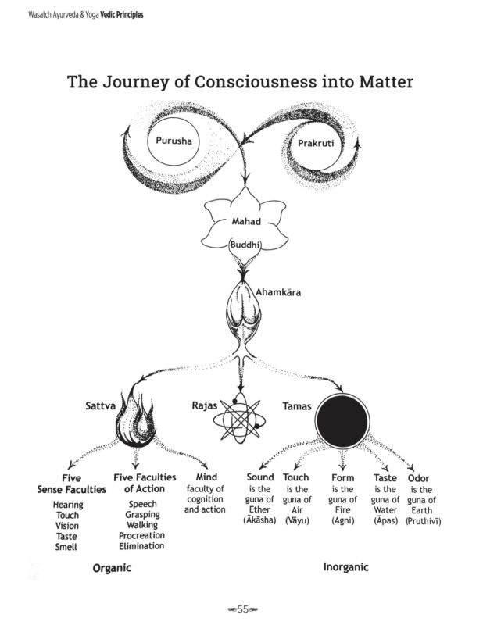

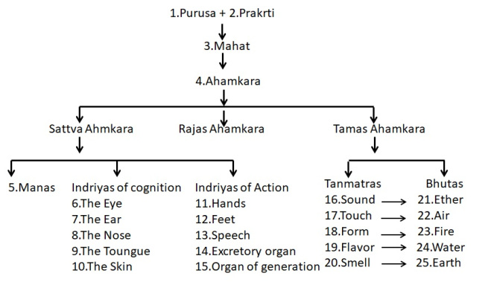

Liberation or mokṣa-
Samkhya regards ignorance (avidyā) as the root cause of suffering and bondage (Samsara). Samkhya states that the way out of this suffering is through knowledge (viveka). Mokṣa (liberation), states Samkhya school, results from knowing the difference between prakṛti (avyakta-vyakta) and puruṣa (jña).^{[5]}
Puruṣa, the eternal pure consciousness, due to ignorance, identifies itself with products of prakṛti such as intellect (buddhi) and ego (ahamkara). This results in endless transmigration and suffering. However, once the realization arises that puruṣa is distinct from prakṛti, is more than empirical ego, and that puruṣa is deepest conscious self within, the Self gains isolation (kaivalya) and freedom (moksha)

