LAW OF DEMAND AND ELASTICITY OF DEMAND

Meaning of Demand
- In ordinary speech, the term demand is many times confused with ‘desire’ or ‘want’.
- Desire is only a wish to have any thing.
- In economics demand means more than mere desire.
- Demand in economics means an effective desire for a commodity i.e. desire backed by the ‘ability to pay’ and ‘willingness to pay’ for it.
- Thus, demand refers to the quantity of a good or service that consumers are willing and able to purchase at different prices during a period of time.
- Thus, defined, the term demand shows the following features:
- Demand is always with reference to a PRICE.
- Demand is to be referred to IN A GIVEN PERIOD OF TIME.
- Consumer must have the necessary purchasing power to back his desire for the com- modity.
- Consumer must also be ready to exchange his money for the commodity he desires.
- E.g. Mr. A’s demand for sugar at ` 15 per kg. is 4 kgs. per week.

Determinants of Demand
For estimating market demand for its products, a firm must have knowledge about—
- the determinants of demand for its product, and
- the nature of relationship between demand and is determinants.
The various factors on which the demand for a product/commodity depends are as follows:—

Price of the commodity:
  - Other things being equal, the demand for a commodity is inversely related with its price.
  - It means that a rise in price of a commodity brings about fall in its demand and vice versa.
  - This happens because of income and substitution effects.

Price of the related commodities:
- The demand for a commodity also depends on the prices of related commodities.

13

- Related commodities are of two types namely—
  - Substitutes or competitive goods, &
  - Complementary goods.
- Substitute goods are those goods which can be used with equal ease in place of one another.
- E.g. Essar Speed Card and Airtel Magic Card; Coke and Pepsi; ball pen and ink pen; tea and coffee; etc.
- Demand for a particular commodity is affected if the price of its substitute falls or rises.
- E.g. If the price of Airtel Magic card falls, its demand will increase and demand for Essar Speed Card would fall and vice versa.
- Thus, there is a POSITIVE RELATIONSHIP between price of a commodity and demand for its substitutes.
- Complementary good are those goods whose utility depends upon the availability of both the goods as both are to be used together.
- E.g. a ball pen and refill; car and petrol; a hand set and phone connection; a tonga and horse, etc.
- The demand for complementary goods have an INVERSE RELATIONSHIP with the price of related goods.
- E.g. If the price of Scooters falls, its demand will increase leading to increase in demand for petrol.

Income of the consumers
- Other things being equal, generally the quantity demanded of a commodity bear a DIRECT RELATIONSHIP to the income of the consumer i.e. with an increase in income, the demand for a commodity rises.
- However, this may not always hold true. It depends upon the class to which commodity belongs i.e. necessaries or comforts and luxuries or inferior goods:
  - Necessaries (E.g. Food, clothing and shelter). Initially, with an increase in the in- come, the demand for necessaries also rises upto some limit. Beyond that limit, an increase in income will leave the demand unaffected.
  - Comforts and Luxurious (E.g. Car; Air-Conditioners; etc.) Quantity demanded of these group of commodities have a DIRECT RELATIONSHIP with the income of the consumers. As the income increases, the demand for comforts and luxuries also increases.
  - Inferior goods (E.g. Coarse grain; rough cloth; skimmed milk; etc.). Inferior goods are those goods for which superior substitutes are available Quantity demand- ed of this group of commodities Have an INVERSE RELATIONSHIP with the income of the consumer. E.g. A consumer starts consuming full cream milk (normal good) in place of toned milk (inferior good) with an increase in income.
Therefore, it is essential that business managers must know—
- the nature of good they produce,
- the nature of relationship between the quantities demanded and changes in consumer’s income, and
- the factors that could bring about changes in the incomes of the consumers.

TaxMaNN®

Tastes and Preferences of the consumers
- Tastes and preferences of consumers generally change over time due to fashion, advertisements, habits, age, family composition, etc. Demand for a commodity bears a direct relationship to those determinants.
- Modern goods or fashionable goods have more demand than the goods which are of old design and out of fashion.
E.g. People are discarding Bajaj Scooter for say Activa Scooter.
- The demand of certain goods is determined by ‘bandwagon effect’ or ‘demonstration effect’. It means a buyer wants to have a good because others have it. It means that an individual consumer’s demand is conditioned by the consumption of others.
- Taste and preferences may also undergo a change when consumer discover that con- sumption of a good increases his PRESTIGE. E.g. Diamonds, fancy cars, etc.
- A good loses its prestige when it becomes a commonly used good. This is called ‘snob effect’.
- Status seeking rich people buy highly priced goods only. This form of ‘conspicuous consumption’ or ‘ostentatius consumption’ is called ‘VEBLEN EFFECT’ (named after American economist THORSTEIN VEBLEN)
- Tastes and preferences of people change either due to external causes or internal causes.
- Therefore, knowledge about tastes and preferences is important in production planning, designing new products and services to suit the changing tastes and preferences of the consumers.
- Other Factors. Other things being equal demand for a commodity is also determined by the following factors:—

Size and composition of Population:
  - Generally, larger the size of population of a country, more will be the demand of the commodities.
  - The composition of the population also determines the demand for various com- modities.
E.g. If the number of teenagers is large, the demand for trendy clothes, shoes, movies, etc. will be high.

The level of National Income and its Distribution:
  - National Income is an important determinant of market demand. Higher the national income, higher will be the demand for normal goods and services.
  - If the income in a country is unevenly distributed, the demand for consumer goods will be less.
  - If the income is evenly distributed, there is higher demand for consumer goods.

Sociological factors:
  - The household’s demand for goods also depends upon sociological factors like class, family background, education, marital status, age, locality, etc.

Weather conditions:
  - Changes in weather conditions also influence household’s demand.
E.g. - Extraordinary hot summer push up the demand for ice-creams, cold drinks, coolers etc.

Advertisement:
  - A clever and continuous campaign and advertisement create a new type of demand.
E.g. Toilet products like soaps, tooth pastes, creams etc.

Government Policy:
- The government’s taxation policy also affects the demand for commodities.
- High tax on a commodity will lead to fall in the demand of the commodity.

Expectation about future prices:
  - If consumers expect rise in the price of a commodity in near future, the current demand for the commodity will increase and vice versa.

Trade Conditions:
  - If the country is passing through boom conditions, demand for most goods is more.
  - But during depression condition, the level of demand falls.

Consumer-credit facility and interest rates:
  - If ample credit facilities with low rates of interest is available, there will be more demand specially of consumer durable goods like scooters, LCD/LED televisions, refrigerators, home theatre, etc.

Demand Function
1. Mathematical/symbolic statement of functional relationship between the demand for a product (the dependent variable) its determinants (the independent variables) is called demand function
Dx = f (Px, M, Ps ; Pc, T, A)
Thhere—
Dx= quantity demanded of product × Px = the price of the product ×
M = money income of the consumer Ps = the price of its substitute
Pc = the price of its complementary goods
T = consumer’s tastes and preferences
A = advertising effect measured through the level of advertisement expenditure.

The Law of Demand
- The Law of Demand expresses the nature of functional relationship between the price of a commodity and its quantity demanded.
- It simply states that demand varies inversely to the changes in price i.e. demand for a com- modity expands when price falls and contracts when price rises.

“Law of Demand states that people will buy more at lower prices and buy less at higher prices, other things remaining the same.” (Prof. Samuelson)
- It is assumed that other determinants of demand are constant and ONLY PRICE IS THE VARIABLE AND INFLUENCING FACTOR.
- Thus, the law of demand is based on the following main assumptions:—
- Consumers income remain unchanged.

TaxMaNN®
- Tastes and preferences of consumers remain unchanged.
- Price of substitute goods and complement goods remain unchanged.
- There are no expectations of future changes in the price of the commodity.
- There is no change in the fashion of the commodity etc.
- The law can be explained with the help of a demand schedule and a corresponding demand curve.
- Demand schedule is a table or a chart which shows the different quantities of commodity demanded at different prices in a given period of time.
- Demand schedule can be Individual Demand Schedule or Market Demand Schedule.
- Individual Demand Schedule is a table showing different quantities of commodity that ONE PARTICULAR CONSUMER is willing to buy at different level of prices, during a given period of time

Table 1 : Demand Scheduled of an Individual Buyer

Price of sugar ` per kg. | Quantity Demanded kgs. per month
1 | 5
2 | 4
3 | 3
4 | 2
5 | 1
- Market Demand Schedule is a table showing different quantities of a commodity that ALL THE CONSUMERS are willing to buy at different prices, during a given period of time.

Table 2 : Market Demand Schedule

Price of sugar ` per kg. | Quantity Demanded p.m. kgs. |  | Market Demand  A + B
Price of sugar ` per kg. | Consumer A | Consumer B | Market Demand  A + B
1 | 5 | 6 | 5 + 6 = 11
2 | 4 | 5 | 4 + 5 = 9
3 | 3 | 4 | 3 + 4 = 7
4 | 2 | 3 | 2 + 3 = 5
5 | 1 | 2 | 1 + 2 = 3
(Assumption: There are only 2 buyers in the market)
- Both individual and market schedules denotes an INVERSE functional relationship between price and quantity demanded. In other words, when price rises demand tends to fall and vice versa.
A demand curve is a graphical representation of a demand schedule or demand function.
- A demand curve for any commodity can be drawn by plotting each combination of price and demand on a graph.
- Price (independent variable) is taken on the Y-axis and quantity demanded (dependent vari- able) on the X-axis.

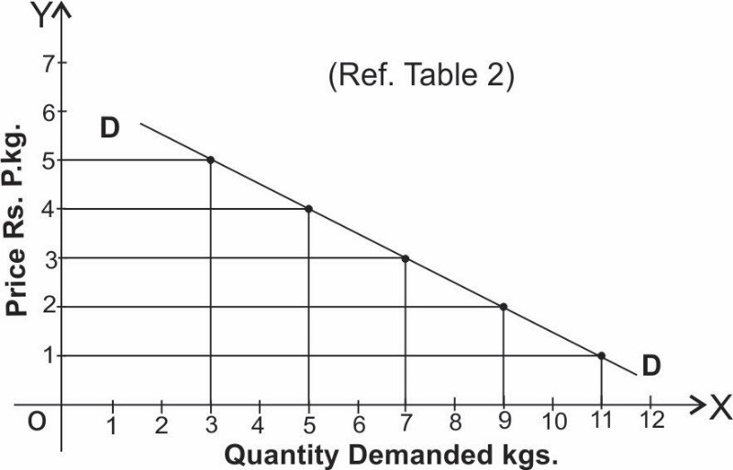

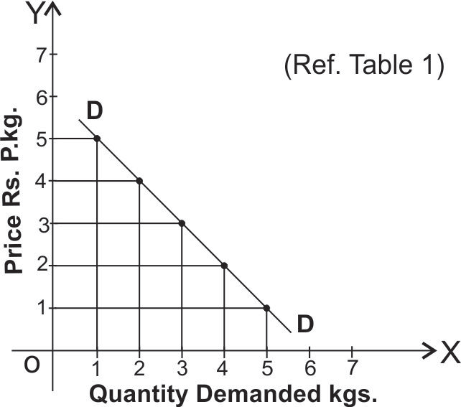
Figure: Market Demand Curve
Figure: Individual Demand Curve
- Individual Demand Curve as well as Market Demand Curve slope downward from left to right indicating an inverse relationship between own price of the commodity and its quantity demanded.

Market Demand Curve is flatter than individual Demand Curve.
- Reasons for the law of demand and downward slope of a demand curve are as follows:—

The Law of Diminishing Marginal Utility:
  - According to this law, other things being equal as we consume a commodity, the marginal utility derived from its successive units go on falling.
  - Hence, the consumer purchases more units only at a lower price.
  - A consumer goes on purchasing a commodity till the marginal utility of the commodity is greater than its market price and stops when MU = Price i.e. when consumer is at equilibrium.
  - Thhen the price of the commodity falls, MU of the commodity becomes greater than price and so consumer start purchasing more till again MU = Price.
  - It therefore, follows that the diminishing marginal utility implies downward sloping demand curve and the law of demand operates.

Change in the number of consumers:
  - Many consumers who were unable to buy a commodity at higher price also start buying when the price of the commodity falls.
  - Old customers starts buying more when price falls.

Various uses of a commodity:
  - Commodity may have many uses. The number of uses to which the commodity can be put will increase at a lower price and vice versa.

Income effect:
  - Thhen price of a commodity falls, the purchasing power (i.e. the real income) of the consumer increases.
  - Thus he can purchase the same quantity with lesser money or he can get more quantity for the same money.
  - This is called income effect of the change in price of the commodity.

