Sources of Finance
Financial Management
Prof. Sreemoyee Datta
Seth Anandram Jaipuria College
Department of Commerce - Morning
Introduction
- Sources of finance for business are equity, debt, debentures, retained earnings, term loans, working capital loans, letter of credit, euro issue, venture funding etc. These sources of funds are used in different situations. They are classified based on time period, ownership and control, and their source of generation. It is ideal to evaluate each source of capital before opting for it.
- Sources of capital are the most explorable area especially for the entrepreneurs who are about to start a new business. It is perhaps the toughest part of all the efforts. There are various capital sources, we can classify on the basis of different parameters.
- Choosing the right source and the right mix of finance is a key challenge for every finance manager. The process of selecting the right source of finance involves in-depth analysis of each and every source of fund.
- There are many characteristics on the basis of which sources of finance are classified. On the basis of a time period, sources are classified as long-term, medium term, and short term. Ownership and control classify sources of finance into owned and borrowed capital. Internal sources and external sources are the two sources of generation of capital.
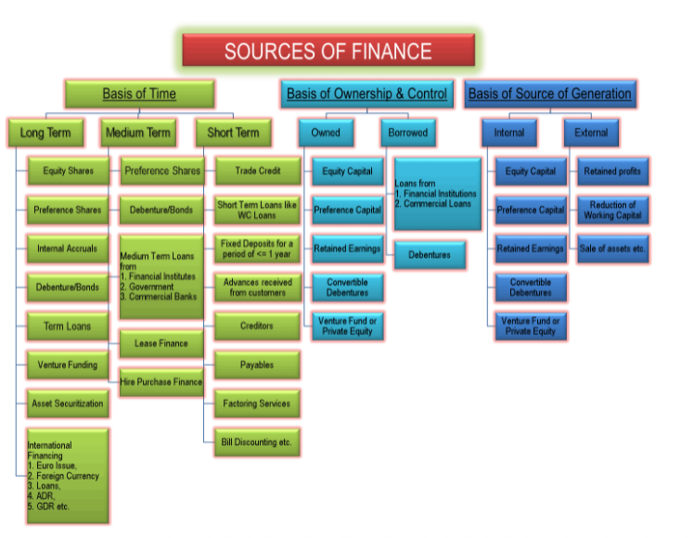

According to Time Period:
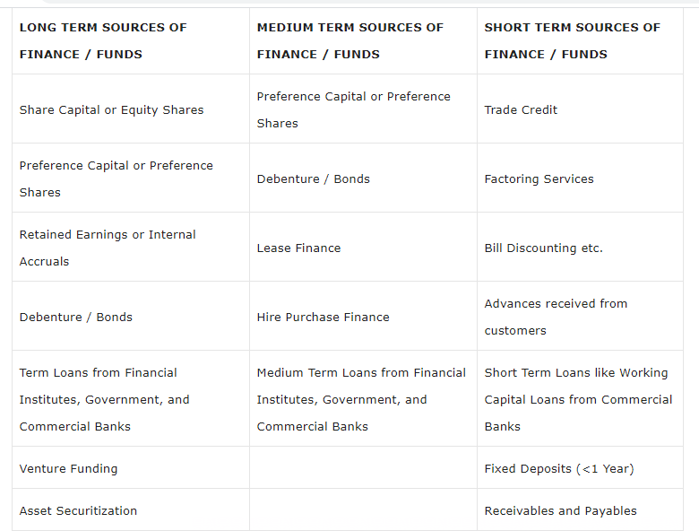Long-Term Sources of Finance
- Long-term financing means capital requirements for a period of more than 5 years to 10, 15, 20 years or maybe more depending on other factors. Capital expenditures in fixed assets like plant and machinery, land and building, etc. of business are funded using long-term sources of finance. Part of working capital which permanently stays with the business is also financed with long-term sources of funds. Long-term financing sources can be in the form of any of them:
- Share Capital or Equity Shares
- Preference Capital or Preference Shares
- Retained Earnings or Internal Accruals
- Debenture / Bonds
- Term Loans from Financial Institutes, Government, and Commercial Banks
- Venture Funding
- Asset Securitization
- International Financing by way of Euro Issue, Foreign Currency Loans, etc.
Medium Term Sources of Finance
- Medium term financing means financing for a period of 3 to 5 years and is used generally for two reasons. One, when long-term capital is not available for the time being and second, when deferred revenue expenditures like advertisements are made which are to be written off over a period of 3 to 5 years. Medium term financing sources can in the form of one of them:
- Preference Capital or Preference Shares
- Debenture / Bonds
- Medium Term Loans from financial institutes, government, and commercial banks
- Lease Finance
- Hire Purchase Finance
Short Term Sources of Finance
- Short term financing means financing for a period of less than 1 year. The need for short-term finance arises to finance the current assets of a business like an inventory of raw material and finished goods, debtors, minimum cash and bank balance etc. Short-term financing is also named as working capital financing. Short term finances are available in the form of:
- Trade Credit
- Short Term Loans like Working Capital Loans from Commercial Banks
- Fixed Deposits for a period of 1 year or less
- Advances received from customers
- Creditors
- Payables
- Factoring Services
- Bill Discounting etc.
According to Ownership and Control:
- Sources of finances are classified based on ownership and control over the business. These two parameters are an important consideration while selecting a source of funds for the business. Whenever we bring in capital, there are two types of costs – one is the interest and another is sharing ownership and control. Some entrepreneurs may not like to dilute their ownership rights in the business and others may believe in sharing the risk.
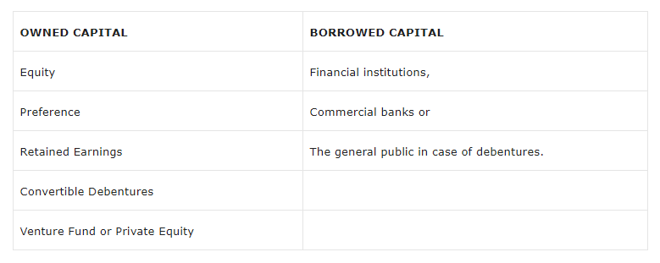

Owned Capital
- Owned capital also refers to equity. It is sourced from promoters of the company or from the general public by issuing new equity shares. Promoters start the business by bringing in the required money for a startup. Following are the sources of Owned Capital:
- Equity
- Preference
- Retained Earnings
- Convertible Debentures
- Venture Fund or Private Equity
- Further, when the business grows and internal accruals like profits of the company are not enough to satisfy financing requirements, the promoters have a choice of selecting ownership capital or non-ownership capital. This decision is up to the promoters. Still, to discuss, certain advantages of equity capital are as follows:
- It is a long-term capital which means it stays permanently with the business.
- There is no burden of paying interest or installments like borrowed capital. So, the risk of bankruptcy also reduces. Businesses in infancy stages prefer equity for this reason.
Borrowed Capital
- Borrowed or debt capital is the finance arranged from outside sources. These sources of debt financing include the following:
- Financial institutions,
- Commercial banks or
- The general public in case of debentures
- In this type of capital, the borrower has a charge on the assets of the business which means the company will pay the borrower by selling the assets in case of liquidation. Another feature of the borrowed fund is a regular payment of fixed interest and repayment of capital. Certain advantages of borrowing are as follows:
- There is no dilution in ownership and control of the business.
- The cost of borrowed funds is low since it is a deductible expense for taxation purpose which ends up saving on taxes for the company.
- It gives the business the benefit of leverage.

According to Sources of Generation:
- Based on the source of generation, the following are the internal and external sources of finance:
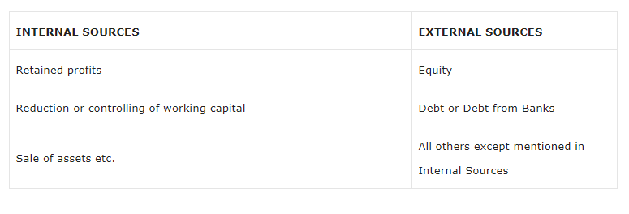Internal Sources
- The internal source of capital is the one which is generated internally by the business. These are as follows:
- Retained profits
- Reduction or controlling of working capital
- Sale of assets etc.
- The internal source of funds has the same characteristics of owned capital. The best part of the internal sourcing of capital is that the business grows by itself and does not depend on outside parties. Disadvantages of both equity and debt are not present in this form of financing. Neither ownership dilutes nor fixed obligation/bankruptcy risk arises.
External Sources
- An external source of finance is the capital generated from outside the business. Apart from the internal sources of funds, all the sources are external sources.
- Deciding the right source of funds is a crucial business decision taken by top-level finance managers. The usage of the wrong source increases the cost of funds which in turn would have a direct impact on the feasibility of the project under concern. Improper match of the type of capital with business requirements may go against the smooth functioning of the business. For instance, if fixed assets, which derive benefits after 2 years, are financed through short-term finances will create cash flow mismatch after one year and the manager will again have to look for finances and pay the fee for raising capital again.

Basic Definitions
- Commercial Paper - Commercial paper is a money-market security issued (sold) by large corporations to obtain funds to meet short-term debt obligations (for example, payroll) and is backed only by an issuing bank or company promise to pay the face amount on the maturity date specified on the note. It is a commonly used type of unsecured, short-term debt instrument, typically used for the financing of payroll, accounts payable and inventories, and meeting other short-term liabilities.
- Factoring - Factoring is a financial transaction and a type of debtor finance in which a business sells its accounts receivable (i.e. invoices) to a third party (called a factor) at a discount. A business will sometimes factor its receivable assets to meet its present and immediate cash needs. It is a financial service in which the business entity sells its bill receivables to a third party at a discount in order to raise funds. Factoring involves the selling of all the accounts receivable to an outside agency. Such an agency is called a factor.
- Hire purchase - Hire purchase is an arrangement made while buying expensive goods. The consumer makes a down payment during the purchase, and the outstanding balance will be paid in instalments with an interest charge. There is a similar concept called a mortgage. Usually, mortgage involves pledging an item previously owned by the borrower in order to fetch some spending money, and the ownership of the item will be transferred to the lender as long as they repay the debt. In hire purchase, the borrower purchases a new item. In both cases, the ownership of the purchased goods will be transferred to the lender until the borrower pays off the whole debt.
- Leasing - A lease is a contract outlining the terms under which one party agrees to rent property owned by another party. It guarantees the lessee, also known as the tenant, use of an asset and guarantees the lessor, the property owner or landlord, regular payments for a specified period in exchange.
- Hire Purchase vs. Lease - In a lease, ownership lies with the lessor. The lessee has the right to use the equipment and does not have the option to purchase. Whereas in hire purchase, the hirer has the option to purchase. The hirer becomes the owner of the asset/equipment immediately after the last installment is paid.
- Public Deposits - Public deposits refer to the unsecured deposits invited by companies from the public mainly to finance working capital needs. A company wishing to invite public deposits makes an advertisement in the newspapers. Any member of the public can fill up the prescribed form and deposit the money with the company. The company in return issues a deposit receipt. This receipt is an acknowledgement of debt by the company. A company can invite public deposits for a period of six months to three years. Therefore, public deposits are primarily a source of short-term finance. Companies prefer public deposits because these deposits are cheaper than bank loans. The public prefers to deposit money with well-established companies because the rate of interest on public deposits is higher than that of bank deposits.
- Convertible Debentures - A convertible debenture is usually an unsecured bond or a loan as in there is no primary collateral interlinked to the debt. They are long-term debt securities that pay interest returns to the bondholder. A unique feature of convertible debentures is that they can be converted into stock at specified times. The option of converting debentures into equity shares lies with the holder. A convertible debenture will provide regular interest income via coupon payments and repayment of the principal amount at maturity.
Difference between Hire Purchase & Leasing
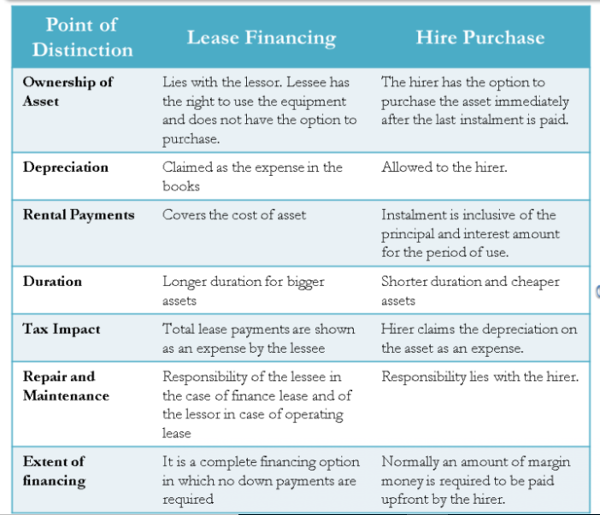
- Term Financing - A term financing is a loan from a bank for a specific amount that has a specified repayment schedule and either a fixed or floating interest rate. A term loan is often appropriate for an established small business with sound financial statements. Also, a term loan may require a substantial down payment to reduce the payment amounts and the total cost of the loan. Companies often use a term loan's proceeds to purchase fixed assets, such as equipment or a new building for its production process.
- Ploughing Back of Profits - The ‘Ploughing Back of Profits’ is a management policy under which all profits are not distributed amongst the shareholders, but a part of the profit is ‘Ploughed back’ or retained in the company. It is also known as ‘retained earnings’ or ‘accrual profit’. These retained earnings are utilized in future for financing modernization and expansion programmes and for meeting the fixed or working capital needs of the company. Since it means dependence on internal sources for meeting the financial needs of the company, it is also called ‘Internal Financing’ or ‘Self Financing’. A reasonable part of the total earnings is transferred to various reserves like General Reserve Fund, Repairs and Renewal or Depreciation Fund, Replacement Fund etc. Sometimes Secret Reserves are also created without the knowledge of owners of capital. The practice of retained earnings is appreciated because it helps in stabilizing the economic soundness of a company.
- Euro Issue - Euro issue is a name given to sources of finance or capital available to raise money outside the home country in foreign currency. The most commonly used sources of funds that fall under Euro issues are American Depository Receipts (ADR), Global Depository Receipts (GDR), and Foreign Currency Convertible Bonds (FCCB) among others.
- Working Capital Loans - A working capital loan is a loan that is taken to finance a company's everyday operations. These loans are not used to buy long-term assets or investments and are, instead, used to provide the working capital that covers a company's short-term operational needs. Those needs can include costs such as payroll, rent, and debt payments. In this way, working capital loans are simply corporate debt borrowings that are used by a company to finance its daily operations. Working capital loans are not used to buy long-term assets or investments; they are used to provide working capital to cover a company's short-term operational needs.
- Trade Credit - Trade credit is a business-to-business (B2B) agreement in which a customer can purchase goods without paying cash up front, and paying the supplier at a later scheduled date. Usually, businesses that operate with trade credits will give buyers 30, 60, or 90 days to pay, with the transaction recorded through an invoice. Trade credit can be thought of as a type of 0% financing, increasing a company’s assets while deferring payment for a specified value of goods or services to sometime in the future.
- Letter of Credit - A letter of credit, or "credit letter" is a letter from a bank guaranteeing that a buyer's payment to a seller will be received on time and for the correct amount. In the event that the buyer is unable to make a payment on the purchase, the bank will be required to cover the full or remaining amount of the purchase. It may be offered as a facility. Due to the nature of international dealings, including factors such as distance, differing laws in each country, and difficulty in knowing each party personally, the use of letters of credit has become a very important aspect of international trade. Banks also collect a fee for service, typically a percentage of the size of the letter of credit. Banks typically require a pledge of securities or cash as collateral for issuing a letter of credit.
- Venture Funding - Venture capital is a form of private equity and a type of financing that investors provide to startup companies and small businesses that are believed to have long-term growth potential. Venture capital generally comes from well-off investors, investment banks, and any other financial institutions.

THANK YOU

