Auditing & Assurance
Concept, Need & Purpose of Audit
B. Com Hons. Semester (V)
Prof. Sreemoyee Datta
Seth Anandram Jaipuria College
Department of Commerce (Morning)
Contents:
- Introduction
- Definition of Audit
- Meaning of Audit
- Origin & Evolution of Audit
- Objectives of Audit
- Errors & Frauds
- Auditor’s Duty relating to errors and frauds
- Characteristics/Features of Audit
- Functions of Audit
- Advantages of Audit
- Limitations of Audit
- Qualities of an Auditor
Introduction
Audit is an intelligent and critical examination of the books of accounts of the business. Auditing is done by an independent person or body of persons qualified for the job with the help of statements, papers, information and comments received from the authorities so that the examiner can confirm the authenticity of financial accounts prepared for a fixed term and report that:
- Whether the balance sheet exhibits a true and fair view of the state of affairs of concern;
- Whether the profit and loss account reveals the right and balanced view of the profit and loss for the financial period;
- And lastly, whether the accounts have been prepared in conformity with the law.
True & Fair View
A true and fair view in accounting (specifically auditing) means that a financial statement is free from material misstatements and faithfully represents the financial performance and positioning of an entity. True and fair is the term used in an audit report of financial statements to express the condition that financial statements are truly prepared and fairly presented in accordance with the prescribed accounting standards.

True View:
- An audit report can be called true, when the financial statements are free from error or fraud. The financial statements are true when all kinds of errors are being taken under consideration.
- Financial statements are truly prepared when they are respected and followed by the accounting standards and frameworks that the company is using to prepare the statements.
Fair View:
- It means that the financial transactions are treated fairly as they should be and all significant information is sufficiently disclosed in the financial statements to ensure that the users are not being misled.
- The fair view mainly focuses on the ways how the quality of the information in the financial statements is.
Definition & Meaning of Audit
Definition of Auditing/Audit:
According to the ICAI, ‘audit is the independent examination of the financial information of any entity, whether profit oriented or not, and irrespective of its size and legal form, when such an examination is conducted with a view to expressing an opinion there upon.’
Meaning of Auditing:
The term audit is derived from a Latin word “audire” or “audere” which means ‘to hear’. The authenticity of accounts is assured with the help of an independent review. Audit is performed to ascertain the validity and reliability of information. Examination of books and accounts with supporting vouchers and documents to detect and prevent error and fraud is one of the main functions of auditing.
Auditing Origin and Evolution:
- The auditing origin can be traced back to the 18th century, when the practice of large scale production was developed as a result of the Industrial Revolution.
- The industrial revolution led to a significant expansion in the volume of trading transactions which compelled the use of more money, and the ordinary traders were enforced to combine with partnership.
- Consequently, a big enterprise was framed in the form of partnership firms and joint-stock companies.
- This growth of business enterprises before and after the revolution accompanied an improved accounting system.
- Besides, the British Companies made stockholders realize that an independent and impartial audit could well protect their interest.
- Such developments had a direct effect on the evolution of the practice of auditing.
- A Royal Charter incorporated the Institute of Chartered Accountants in England and Wales on May 11, 1880. The key purpose of this incorporation was to prepare Auditors.
Objectives of Auditing
There are two main objectives of Auditing.
- Primary Objective - The main or primary objective of an auditor is to report to owners that whether the financial accounts exhibit a true and fair view of the situation of the company’s activities.
- Secondary Objective - The secondary objective is also known as incidental or ancillary objective as it is related to the fulfillment of the primary purpose. The secondary objectives of auditing are as follows:
- Detection of errors and frauds.
- Prevention of errors and frauds.
Detection of material frauds and errors as an incidental objective of independent financial auditing flows from the primary aim of determining whether or not the financial statements give an accurate and fair view. Frauds can take place due to the manipulation of accounts, and it is essential for the auditor to find the fraud so it can be prevented in the future.
Errors refer to an accidental mistake in the commercial data arising due to ignorance of accounting procedures.
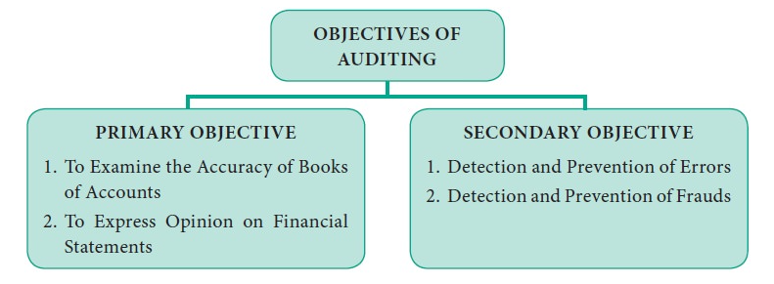
Functions of Auditing:
- Evaluation of internal check and control system – The auditor should see that whether internal check and internal control is present in the organisation or not, and if present, its truthfulness and reliability should be verified.
- Review of accounting principles and policies – One of the main functions of the auditor is to see that whether GAAP, postulates, conventions and concepts are followed while preparation of accounts in the organisation.
- Examination of Documents – For verifying the transaction, the auditor needs to examine all the essential documents of the organisation, for e.g. the MOA, the AOA, partnership deed in case of a partnership firm etc.
- Verification of transactions & asset and liabilities – Verification of assets and liabilities along with other transactions should be properly done for checking its adequacy and truthfulness.
- Submission of Reports – At the end of conducting audit, a report should be submitted by the auditor stating whether the financial statements depict true and fair view or not.
- Providing Advice – Subject to the request of the employer, the drawbacks and defects might be highlighted and necessary suggestions might be given by the auditor.
Errors:
Errors mean mistakes which may arise out of innocence or carelessness on the part of those responsible for preparation of accounts. Errors may be of the following types:
(A) Clerical or Technical Errors – When the mistake on the part of persons engaged in writing are technical in nature, they are called clerical or technical errors. Clerical errors can be of 4 types:
1) Errors of Omission - Errors of omission generally take place due to the mistake of a clerk. If a transaction has not been recorded in the books of accounts either wholly or partially, it is an error of omission.
- E.g.1. A purchase of ₹ 5,000 was made, but no entry was made in the primary books of account.
- E.g.2. Insurance premium was paid for the whole year, but the books show a payment of three quarters only and no entry was made for the outstanding quarter.
- E.g.3. Errors of omission may also arise if a transaction has been recorded in journal but not posted in ledger.
2) Errors of Commission - Errors of commission usually occur because of the negligence of the clerk. If a transaction has been incorrectly recorded in the journal or posted in the ledger, it is called error of commission.
- E.g.1. A purchase invoice of ₹ 1050 has been recorded in the purchase book as ₹ 1500.
- E.g.2. Rent paid to be posted to the credit side of the cash book, posted to the debit side.
3) Errors of Duplication - The error of duplication is another clerical error that may occur due to the accountant’s negligence. If the same transaction has been recorded twice in the books of prime entry and also posted twice in the journal, it is called error of duplication.
- E.g. A purchase invoice of ₹ 5000 may be recorded twice in the account.
4) Compensating Errors - A compensating error is one which is compensated or counterbalanced by any other error or errors. As a result, the adverse effect of one on the debit side or credit is neutralised by the counter effect of another on debit side or credit side.
- E.g.1. A’s account which was to be debited by ₹ 100, was credited by ₹ 100 and B’s account, which was to be credited by ₹ 100, was debited by ₹ 100.
- E.g.2. Rent paid for ₹ 120 was wrongly posted to the debit side of rent account as ₹ 100. Similarly, wages paid for ₹ 100 was wrongly posted to the debit side of wages account as ₹ 120.
(B) Errors of Principle – Errors of principle arise when the transactions are not recorded in the books of accounts according to the fundamental and accepted principles of accounting.
- E.g. Treating capital expenditure as revenue expenditure.

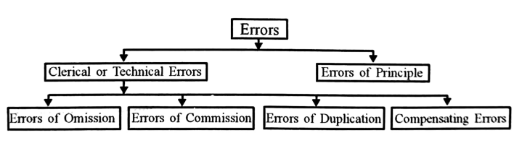
Fraud:
Fraud is a false representation which is made intentionally with some deceitful objective. It may be defined as a successful practice of deception with the intention of cheating or injuring others. Fraud which is committed in accounts may be of two types:
(A) Misappropriation or Defalcation - Misappropriation can again be of two types:
- 1) Misappropriation of Cash
- 2) Misappropriation of Goods
1) Misappropriation of Cash – Misappropriation of cash is an easy affair, especially if the internal checks and control of an organisation is not strong enough. Cash may be misappropriated by the staff by the teeming and lading, omission of entries, fictitious entries, by making fictitious payments, suppression of credit note, inclusion of dummy workers etc.
2) Misappropriation of Goods – Misappropriation of goods are more likely to happen if the goods are less bulky but more valuable. This type of fraud is difficult to detect if there isn’t a systematic internal check.
(B) Fraudulent Manipulation or Falsification of Accounts - Often the high officials of the business in order to fulfil their own interest show the profits and financial position of the company intentionally more or less than the actual position in an artificial way. This is called falsification of accounts or manipulation of accounts. Whenever this type of fraud occurs, it generally involves huge amounts of money and such detection of fraud is quite difficult, as the higher authorities of the company are involved in such a crime.
SA 240: Auditor’s Duty regarding Errors & Frauds:
Scope - SA 240 deals with the auditor’s responsibilities towards frauds in the financial statements. It explains how the material misstatements in the financial statements due to fraud can be identified, assessed and appropriate procedures to detect can be implemented.

Objective:
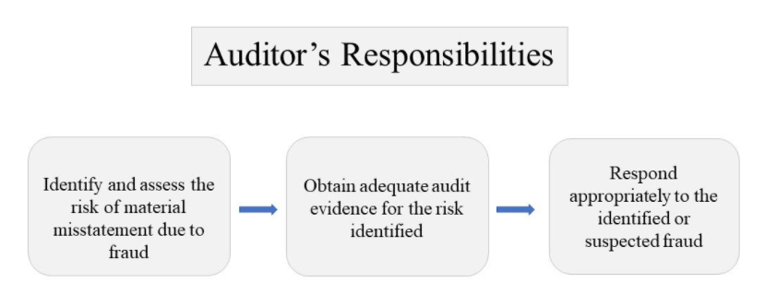
Fraud Characteristics:
Financial statement misstatements arise from either fraud or error. The difference between fraud and error is that the underlying action in the former is intentional. The auditor can suspect or identify but can’t make legal determinations of whether the fraud has actually occurred.
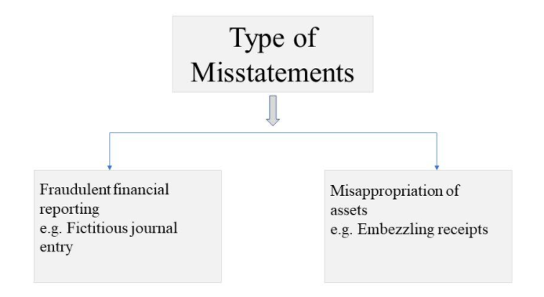
Auditor’s Responsibilities:
- Obtain reasonable assurance that the financial statements are free from material misstatements.
- Maintain professional skepticism throughout the audit.
- The auditor should know that risk of non-detection of management fraud is greater than of employee fraud.
- The auditor must be aware that the risk of non-detection of fraudulent material misstatement is higher than the misstatement due to error.
Is Auditor responsible for the Prevention and Detection of Fraud?
No, Management has the primary responsibility for the prevention and detection of fraud and not the auditor. Management should take all necessary steps for prevention of fraud and errors through implementing adequate policies and controls.
Requirements of Auditor: Collection & Evaluation of Audit Evidence:
- Professional Skepticism – The auditor should maintain professional skepticism while performing an audit, and identify any possible material misstatement due to fraud that could exist despite the auditor’s past experience of management’s honesty and integrity.
- The auditor can accept the records and documents as genuine, unless there is a reason to believe the contrary and investigate if required.
- Investigate the inconsistent responses from the management related to the inquiries.
- SA 315 which covers the Auditor’s response to assessed risks, requires discussion among the engagement team members and the engagement partner on those matters which are to be communicated to other team members not involved in the discussion.
Risk Assessment Procedures:
Following are the Risk assessment procedures:
1. To obtain information which is used for risk identification, auditors shall:
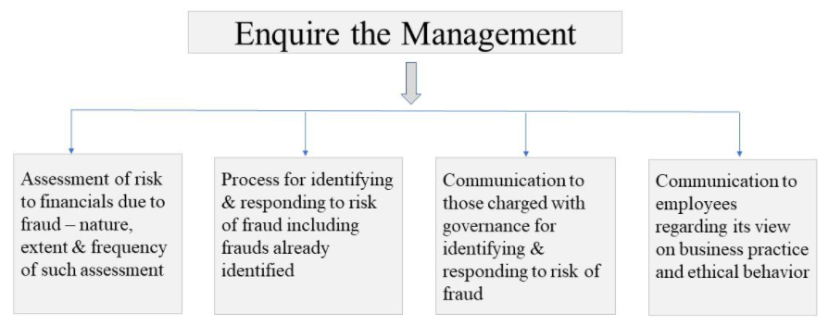
2. Auditors should enquire the management, internal audit team and those charged with governance whether any instance of actual or alleged fraud has occurred in the past and obtain their respective views on the risk of fraud.
3. The auditor should consider whether any other information obtained indicates the risk of fraud.
4. The auditor should evaluate any fraud risk factors are present form the information obtained from the assessment.
5. The auditor should identify anything unusual or unexpected while performing analytical procedure and evaluate them to assess the risk of material misstatement due to fraud.
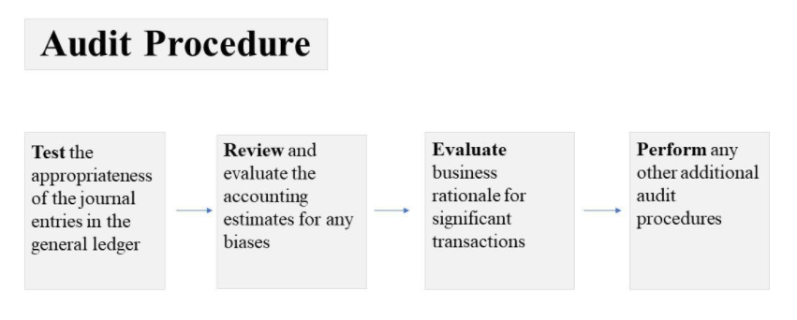
Evaluation of Audit Evidence:
Auditor to follow these with respect to audit evidence:
- Analytical procedure performed indicates a previously unrecognized risk of material misstatement due to fraud.
- On identification of a misstatement, auditor to evaluate whether it is indicative of fraud.
- In case of fraudulent misstatement where auditor believes management is involved, then re-evaluate the response to the assessed risk.
- If unable to conclude if the financial statements are fraudulently misstated, then the auditor to evaluate the implications for the audit.
- If the fraudulent misstatement encounters auditor from continuing the audit, then the auditor shall withdraw from the audit if appropriate and report to the person who made audit appointment.
Communication:
- On identification of fraud or suspecting of fraud existence, then auditor has to communicate to the appropriate level of management on timely basis.
- Communicate as appropriate to those charged with governance if the suspected fraud involves management, the auditor should communicate to the employee performing internal control or any other.
- Determine if the information about the fraud has to be communicated to a party outside the entity. Here the auditor’s legal responsibility overrides the duty of confidentiality.
Documentation:
- Significant decisions taken w.r.t susceptibility of material misstatement in financial due to fraud.
- Identified and assessed risk of material misstatement due to fraud at the financial statements level and at the assertion level.
- Overall responses to the addressed risk mentioned above.
- Audit procedures conclusion including those designed for management controls.
- To document communications made about the fraud to the management and others.
THANK YOU

