The curriculum development process systematically organizes what will be taught, who will be taught, and how it will be taught. Each component affects and interacts with other components. For example, what will be taught is affected by who is being taught (e.g., their stage of development in age, maturity, and education). Methods of how content is taught are affected by who is being taught, their characteristics, and the setting. In considering the above three essential components, the following are widely held to be essential considerations in experiential education in non-formal settings:
Essential Considerations for Curriculum Development:
- issue/problem/need is identified (issue → what),
- characteristics and needs of learners (target audience → who),
- changes intended for learners (intended outcomes/objectives → what the learners will be able to do),
- the important and relevant content →(what),
- methods to accomplish intended outcomes →(how),
- evaluation strategies for methods, content, and intended outcomes →(What works?).

The CURRICULUM DEVELOPMENT MODEL on the next page (Figure 1) shows how these components relate to each other and to the curriculum development process. It begins when an issue, concern, or problem needs to be addressed. If education or training a segment of the population will help solve the problem, then curriculum to support an educational effort becomes a priority with human and financial resources allocated.
The next step is to form a curriculum develop-ment team. The team makes systematic decisions about the target audience (learner characteristics), intended out-comes (objectives), content, methods, and evaluation strategies. With input from the curriculum development team, draft curriculum products are developed, tested, evaluated, and redesigned -if necessary. When the final product is produced, volunteer training is conducted. The model shows a circular process where volunteer training provides feedback for new materials or revisions to the existing curriculum.
An Example: 1n the case of population education, a need rural out-of-school youth with information on how population relates to the total environment as well as their personal lives.

(Insert Curriculum Development Model here)

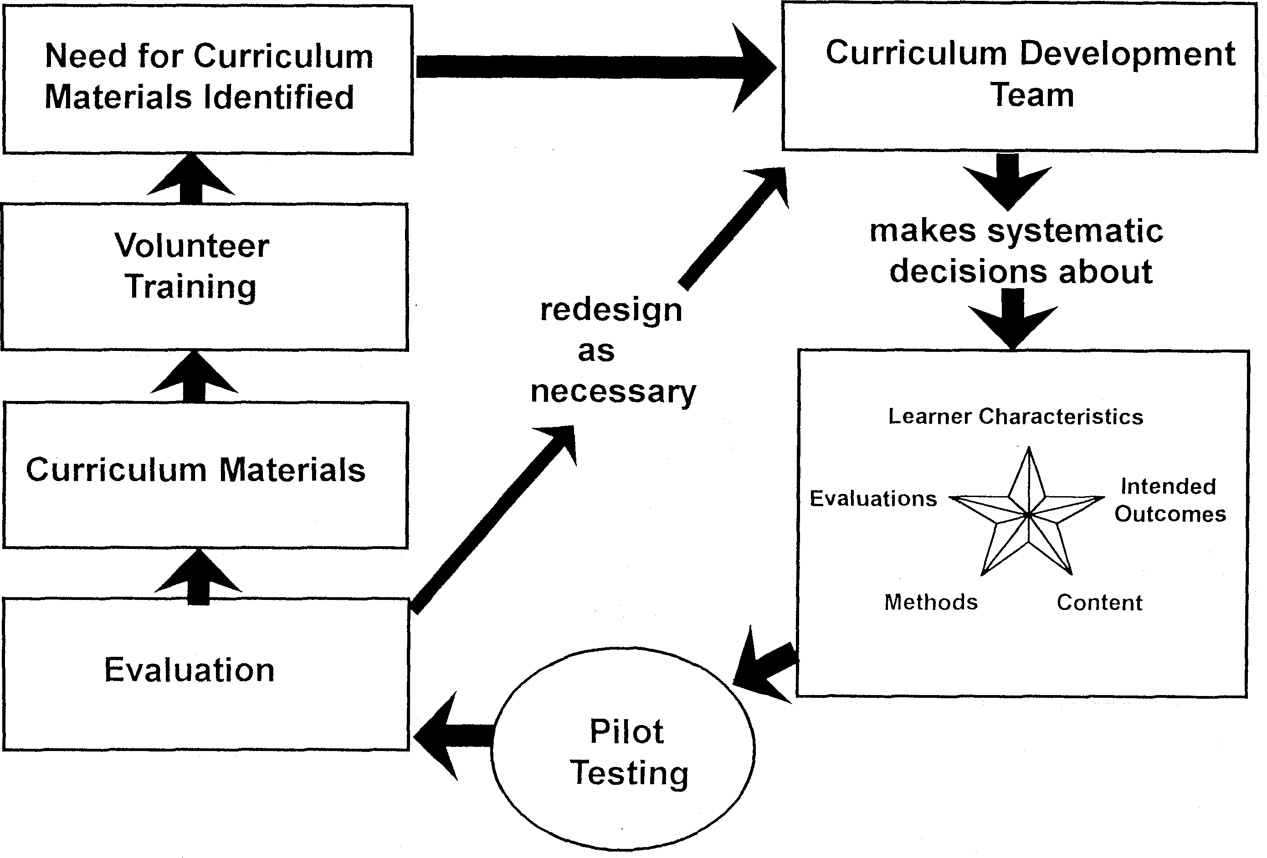
Figure 1

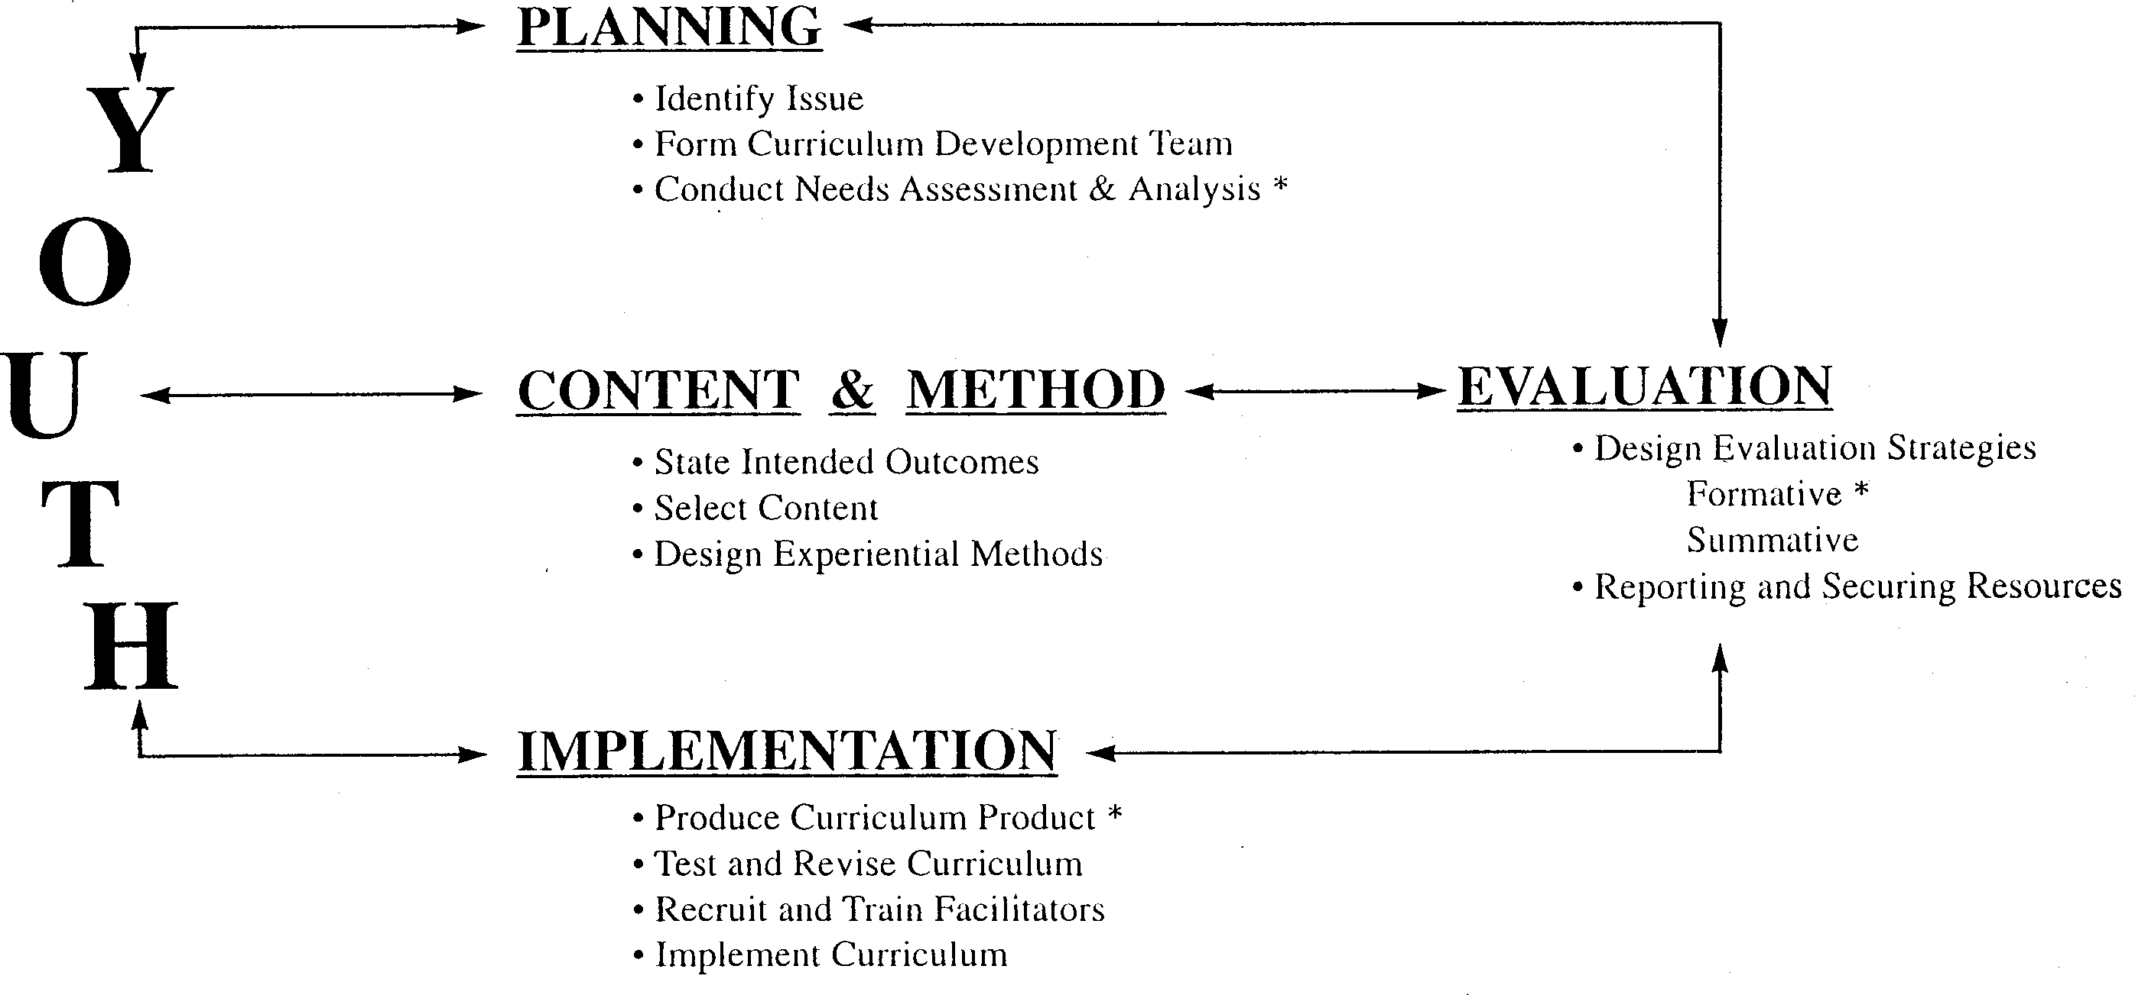
Figure 2
PHASES AND STEPS IN CURRICULUM DEVELOPMENT (See Figure 2 on the previous page) further illustrates how the 12 essential steps progress from one to the next. It also shows the interaction and relationships of the four essential phases of the curriculum development process: ( I) Planning, (II) Content and Methods, (III) Implementation, and (IV) Evaluation and Reporting. It is important to acknowledge that things do not always work exactly as depicted in a model!
Each phase has several steps or tasks to complete in logical sequence. These steps are not always separate and distinct, but may overlap and occur concurrently. For example, the curriculum development team is involved in all of the steps. Evaluations should occur in most of the steps to assess progress. The team learns what works and what does not and determines the impact of the curriculum on learners after it is implemented. Each step logically follows the previous. It would make no sense to design learning activities before learner outcomes and content are described and identified. Similarly, content cannot be determined before learner outcomes are described.
In the experience of the author, and confirmed by other curriculum specialists, the following curriculum development steps are frequently omitted or slighted. These steps are essential to successful curriculum development and need to be emphasized.
Essential Curriculum Development Steps Needing Emphasis
- Needs assessment: if not conducted, wonderful curriculum could be developed, but the appropriate needs of the target audience may not be met.
- Involving youth: the target audience and volunteers (or staff) who will be the implementors of the curriculum must be involved (i.e., they participate as full members of the curriculum development team).
- Recruiting and training volunteer facilitators: competent and skilled curriculum implementors are critical (the printed word cannot teach experiential group process, it doesn't provide feedback).
- Evaluating and reporting on the impact of the curriculum: is critical for securing human and financial support from key policy decision makers and for assessing whether the curriculum has achieved the intended outcome.

Two types of evaluation are included in the Phases and Steps illustration: (1) Formative provides feedback during the process of developing the curriculum, and (2) Summative answers questions about changes (impact) that have occurred in learners because of their learning experiences. Summative evaluation provides evidence for what works, what does not work, and what needs to be improved.
In every step of the curriculum development process, the most important task is to keep the learner (in this case, youth) in mind and involve them in process. For example, the curriculum team members, who have direct knowledge of the target audience, should be involved in conducting the needs assessment. From the needs assessment process, the problem areas are identified, gaps between what youth know and what they need to know are identified, and the scope of the problem is clarified and defined. The results may prompt decision makers to allocate resources for a curriculum development team to prepare curriculum materials.
A brief description of each of the curriculum development steps is described below. After reviewing these descriptions, you should have a very clear idea of how the steps occur in each of the phases and what each step includes.

PHASE I: PLANNING
"Nobody plans to fail but failure results from a failure to plan."
The planning phase lays the foundation for all of the curriculum development steps. The steps in this phase include:
(1) Identify Issue/Problem/Need
↪(2) Form Curriculum Development Team
↪(3) Conduct Needs Assessment and Analysis

(1) Identify Issue/Problem/Need
The need for curriculum development usually emerges from a concern about a major issue or problem of one or more target audience. This section explores some of the questions that need to be addressed to define the issue and to develop a statement that will guide the selection of the members of a curriculum development team. The issue statement also serves to broadly identify, the scope (what will be included) of the curriculum content.

(2) Form Curriculum Development Team
Once the nature and scope of the issue has been broadly defined, the members of the curriculum development team can be selected. Topics covered in this section include: (1) the roles and functions of team members, (2) a process for selecting members of the curriculum development team, and (3) principles of collaboration and teamwork. The goal is to obtain expertise for the areas included in the scope of the curriculum content among the team members and develop an effective team.

(3) Conduct Needs Assessment and Analysis
There are two phases in the needs assessment process. The first is procedures for conducting a needs assessment. A number of techniques are aimed toward learning what is needed and by whom relative to the identified issue. Techniques covered in this section include: KAP - Knowledge, Attitude, and Practice Survey; focus groups; and environmental scanning.
Analysis, the second part of this needs assessment step, describes techniques on how to use the data and the results of the information gathered. Included are: ways to identify gaps between knowledge and practice; trends emerging from the data; a process to prioritize needs; and identification of the characteristics of the target audience.
"As the twig is bent, so grows the tree"

PHASE II: CONTENT AND METHODS
Phase II determines intended outcomes (what learners will be able to do after participation in curriculum activities), the content (what will be taught), and the methods (how it will be taught). Steps include:
(4) State Intended Outcomes
↪ (5) Select Content
↪(6) Design Experiential Methods

(4) State Intended Outcomes
Once the issue is defined, the curriculum team is formed, the needs assessed, analyzed and prioritized, the next step is to refine and restate the issue, if needed, and develop the intended outcomes or educational objectives. An intended outcome states what the learner will be able to do as a result of participating in the curriculum activities.
This section includes: (1) a definition of intended outcomes, (2) the components of intended outcomes (condition, performance, and standards), (3) examples of intended outcomes, and (4) an overview of learning behaviors. A more complete explanation of the types and levels of learning behaviours is included in the Addendum as well as intended outcome examples from FAO population education materials.

(5) Select Content
The next challenge in the curriculum development process is selecting content that will make a real difference in the lives of the learner and ultimately society as a whole. At this point, the primary questions are: "If the intended outcome is to be attained, what will the learner need to know? What knowledge, skills, attitudes, and behaviours will need to be acquired and practiced?"
The scope (breadth of knowledge, skills, attitudes, and behaviours) and the sequence (order) of the content are also discussed. Intended outcomes of population education with content topics is provided in the Addendum section as an example and application of how intended outcomes are linked with content.

(6) Design Experiential Methods
After the content is selected, the next step is to design activities (learning experiences) to help the learner achieve appropriate intended outcomes. An experiential learning model and it's components (i.e., experience, share, process, generalize, and apply) are discussed in this section.
Additional topics include:
- learning styles and activities appropriate for each style;
- a list of types of activities (with descriptions);
- an activity design worksheet for facilitators; and
- brief discussions on learning environments and delivery modes.
Ten population education sample activity sheets along with tips for facilitators working with youth and dealing with sensitive topics are included in the Addendum.

PHASE III:IMPLEMENTATION
(7) Produce Curriculum Product
↪(8) Test and Revise Curriculum
↪(9) Recruit and Train Facilitators
↪(10) Implement Curriculum

(7) Produce Curriculum Product
Once the content and experiential methods have been agreed upon, the actual production of curriculum materials begins. This section includes: 1) suggestions for finding and evaluating existing materials; 2) evaluation criteria; and 3) suggestions for producing curriculum materials.

(8) Test and Revise Curriculum
This step includes suggestions to select test sites and conduct a formative evaluation of curriculum materials during the production phase. A sample evaluation form is provided.

(9) Recruit and Train Facilitators
It is a waste of resources to develop curriculum materials if adequate training is not provided for facilitators to implement it. Suggestions for recruiting appropriate facilitators are provided with a sample three-day training program.

(10) Implement Curriculum
Effective implementation of newly developed curriculum products is unlikely to occur without planning. Strategies to promote and use the curriculum are discussed in this step.

PHASE IV: EVALUATION AND REPORTING
(11) Design Evaluation Strategies
↪(12) Reporting and Securing Resources

(11) Design Evaluation Strategies
Evaluation is a phase in the curriculum development model as well as a specific step. Two types of evaluation, formative and summative, are used during curriculum development. Formative evaluations are used during the needs assessment, product development, and testing steps. Summative evaluations are undertaken to measure and report on the outcomes of the curriculum. This step reviews evaluation strategies and suggests simple procedures to produce valid and reliable information. A series of questions are posed to guide the summative evaluation process and a sample evaluation format is suggested.

(12) Reporting and Securing Resources
The final element in an evaluation strategy is "delivering the pay off (i.e., getting the results into the hands of people who can use them). In this step, suggestions for what and how to report to key shareholders, especially funding and policy decision makers, are provided and a brief discussion on how to secure resources for additional programming.
## ## ##

