Reactive Intermediates
Classical Carbocations
There are four organic species in which a carbon atom has a valence of only 2 or 3. They are usually very short-lived, and most exist only as intermediates that are quickly converted to more stable molecules. However, some are more stable than others and fairly stable examples have been prepared of three of the four types.
The four types of species are carbocations (A), free radicals (B), carbanaions (C), and carbenes (D). Of the four, only carbanions have a complete octet around the carbon. There are many other organic ions and radicals with charges and unpaired electrons on atoms other than carbon, but we will discuss only nitrenes (E), the nitrogen analogs of carbenes.
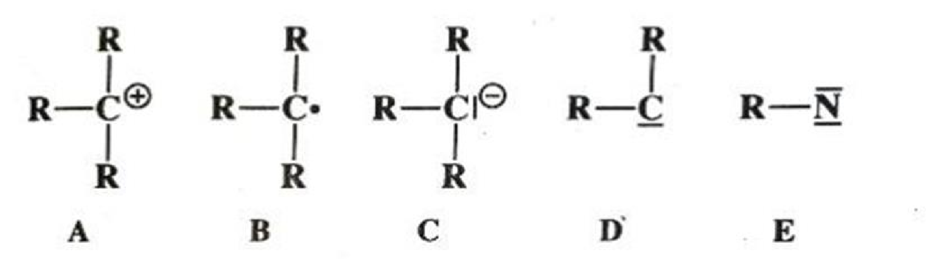
Each of the five types is discussed in separated, which in each case includes brief summaries of the ways in which the species form and react.
These summaries are short and schematic. The generation and fate of the five types are more fully treated in appropriate places in part 2 of this book.

Carbocations
( Classical )
Nomenclature
First we must say a word about the naming of A. For many years these species were called “carbonium ions,” do it was suggested as long ago as 1902 that this was inappropriate because “-onium” usually refers to a covalency higher then that of a neutral atom.
Nevertheless the name “carbonium ion” was well established and created few problems until some years ago, when George Olah and his co-workers found evidence for another type of intermediate in which there is a positive charge at a carbon atom, but in which the formal valency of carbon atom is five rather than three. The simplest example is the methanonium ion CH₅⁺. The mithunonium ion CH₅⁺ has a 3 center two-electron bond. Olah proposed that name ‘carboniun ion’ be henceforth reserved for pentacoordinated positive ions, and that A as carbonium ions and others call them carbenium ions, the general tendency is to refer to them simply as carbocations and we will follow this practice. The pentavalent species are much rarer than A and the use of the term “carbocations” for A causes little or no confusion.

Stability and structure.
Carbocations are intermediates in several kinds of reactions. The more stable ones have been prepared in the solution and in some cases even as solid salts.
In solution the carbocation may be free (this is more likely in polar solvents, in which it is solvated) or it may exist as an iron pair, which means it is closely associated with a negative ion, called a counterion or gengenion. Iron are mire likely in nonpolar solvents. Among simple alkyl carbocations the order of stability is tertiary > secondary > primary.
Many examples are known of the rearrangements of the primary or secondary carbocations to tertiary, both in solution and in gas phase. Since simple alkyl actions are not stable in the ordinary strong acid solution, e.g., H₂ SO₄ , the study of these species was greatly faciliated by the discovery that many if them could be kept indefinitely in stable solutions mixture of fluorosulphuric acid and antimoby pentafluoride.
Such mixtures, usually dissolve in SO₂ or SO₂ CIF, are among the strongest acidic solutions known and are often called super acids. The original experiments involved the addition of alkyl fluorides to SbF₅.
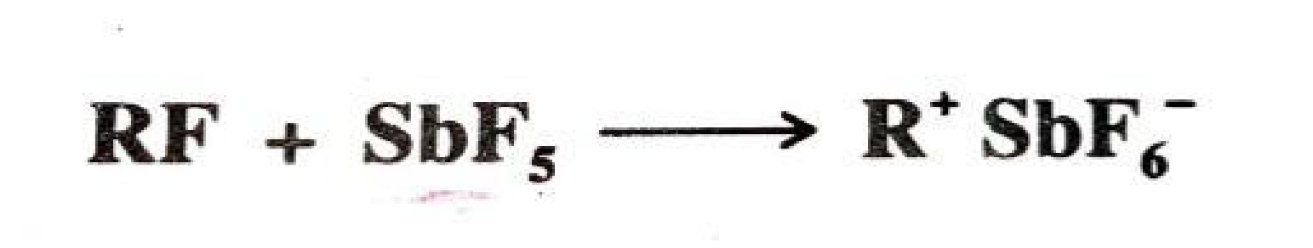
Subsequently it was found that the same cations could also be generated from alcohols in super acid- SO₂ at -60°C and from alkenes by the addition of a proton from super acid or HF-SbF₅ Or SO₂ CIF at low temperatures.
Even alkanes give carbocations in super body by loss of H-. For example, isobutane gives the tbutyl cation.
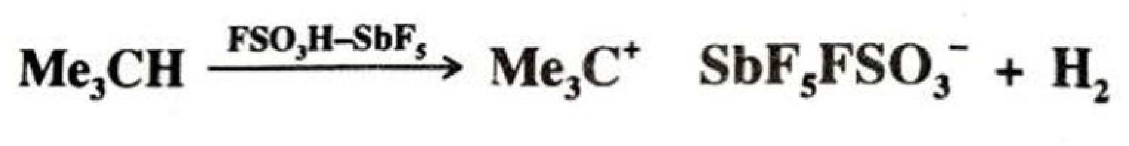
No matter how they are generated, study of the simple alkyl cations gas provided a dramatic evidence for the stability order. Both propyl fluorides gave the the isopropyl cation, and all four butyl flurodes gave t-butyl cation and all seven of the pentyl fluorides tried gave the tpentyl cation. N-butane, in super acid, gave only t-butyl cation. To date no primary cation has survived long enough for detection. Neither methyl nor ethyl fluoride gave chiefly the methylated sulphur dioxide salt (CH₃ OSO) ⁺SbF₆ –while ethyl fluoride rapidly formed the tbutyl and t-hexyl cations by addition of the initially formed ethyl cation to ethylene molecules also formed.
At room temperature, methyl fluoride also gave the t-butyl cation. In accord with the stability order, hydride ion is abstracted from alkanes by super acid most readily from tertiary and least readily from primary positions.
The stability order can be explained by hyperconjugation and by the field effect. In the hyperconjugation explanation we compare a primary carbocation with a tertiary.
It is seen that many more canonical forms are possible for the latter:
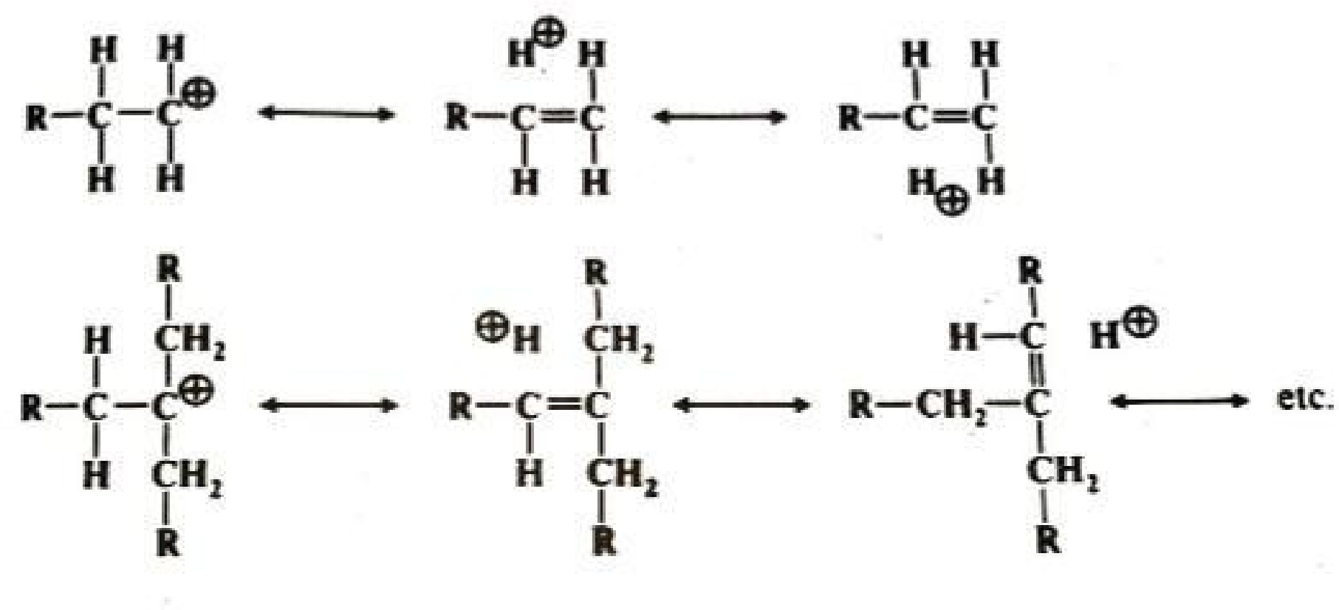
In the examples shown, the primary ion has only two hyperconjugative forms while the tertiary has six. According to the following rrule (6), the greater number of equivalent forms, the greater the resonance stability.
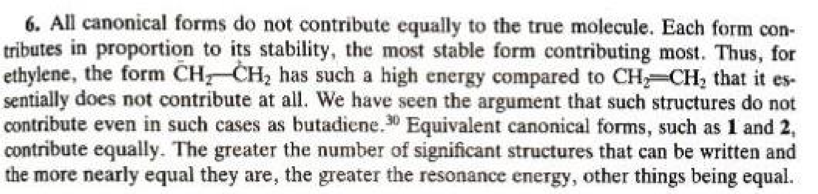
Evidence for the hyperconjugation explanation is that the equilibrium constant for this reaction is 1.97, showing that 2 is more stable than 1.
This is a β secondary isotope effect; there is less hyperconjugationin 1 than in 2. The field effect explanation is that the electron-donating effect of alkyl group increases the electron density at the charge-bearing carbon reducing the net charge on the carbon and in effect spreading the charge over the α carbons. It is a general rule that the more concentrated any charge is the less stable the species bearing it will be. The most stable of all alkyl cations is the t-butyl cation. Even the relatively stable t-pentyl and t-hexyl cations fragment at higher temperatures to produce the t-butyl cation, as do all other alkyl cations with four or more carbons so far studied.
Methane, 22 ethane, and propane, treated with super acid, also yield t-butyl cations as ·the main product. Even paraffin wax and polythyelene give t-butyl cation. Solid salts of t-butyl and t-pentyl cations, e.g. Me₃C⁺ Sbf₆⁻, have been prepared from super acid solutions and are stable below -20°C. Where the positive carbon is in conjugation with a double bond the stability is greater because of increased delocalization due to resonance and because the positive charge is spread over two atoms instead of being concentrated on one.
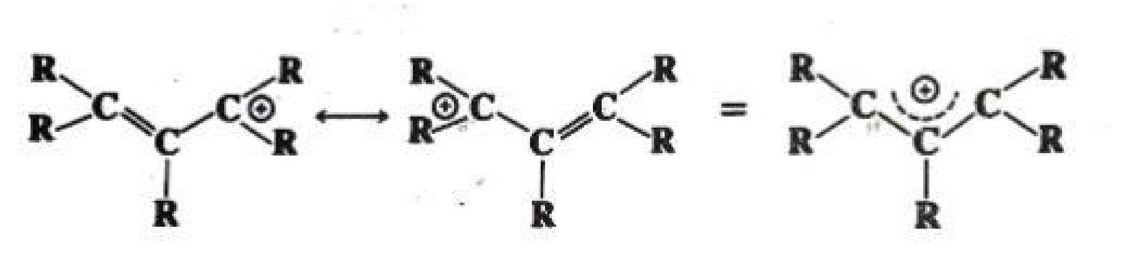
Each of the two atoms has a charge of about ½ (the charge is exactly ½ if all of the R groups are the same). Stable allylic-type cations have been prepared by the solution of the conjugated dienes in concentrated sulfuric acid e.g.,
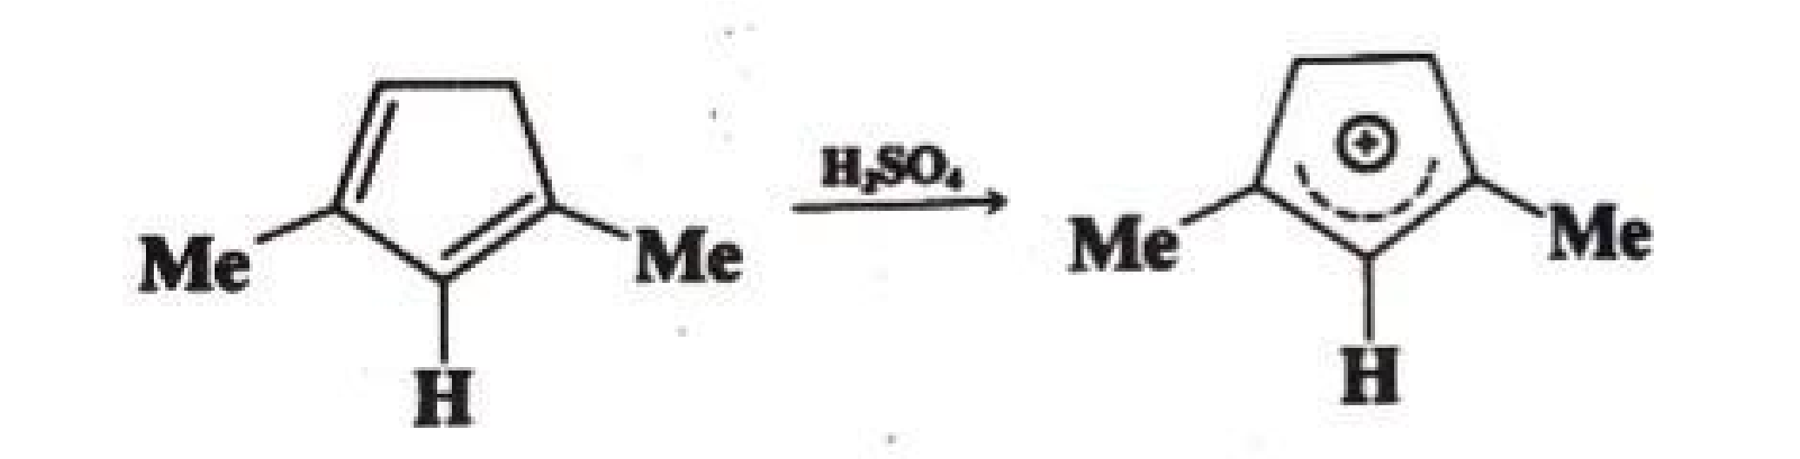
Both cyclic and acyclic allylic cations have been produced in this way. Stable allylic cations have also been obtained by the reaction between alkyl halides, alcohols, or olefins (by hydride extraction) and Sbf₅ in SO₂ or SO₂CIF.
Divinylmethyl cations are more stable than the simple allylic type, some of these have been prepared in concentrated sulfuric acid.
Arenium ions are important examples of this type. Propargyl cations (RC≡CCR₂⁺) have also been prepared.
Canonical forms can be drawn for benzylic cations, similar to those shown above for allylic cations, e.g.,
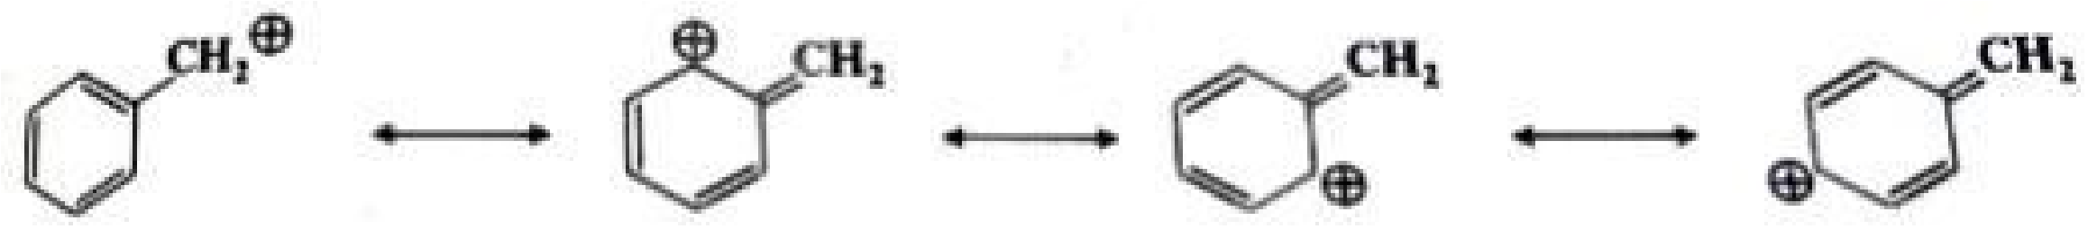
A number of benzylic cations have been obtained in solution as Sbf₆ –salts. Diarylmethyl and triarylmethyl cations are still more stable. Triphenylchloromethane ionizes in polar solvents that do not, like water, react with the ion. In SO₂, the equilibrium has been known for many years.
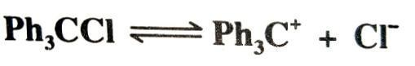
Both triphenylmethyl and diphenylmethyl cations have been isolated as solid salts and, in fact, Ph₃C⁺ BF₄^{-a} and related salts are available com- mercially. Arylmethyl cations are further stabilized if they have electron-donating substi- tuents in ortho or para positions.
Cyclopropylmethyl cations34 are even more stable than the benzyl type. 5 has been preparedby solution of the corresponding alcoholin 96% sulfuricacid,5and 3, 4, and similar ions by solution of the alcohols in FSO₃H–SO₂-Sbf₅. This special stability, which increases with each additional cyclopropyl group, is a result of conjugation between the bent orbitals of the cyclopropyl rings and the vacant p orbital of the Catholic carbon.
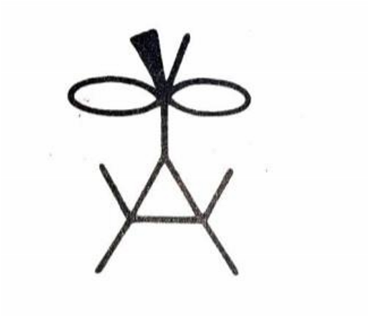
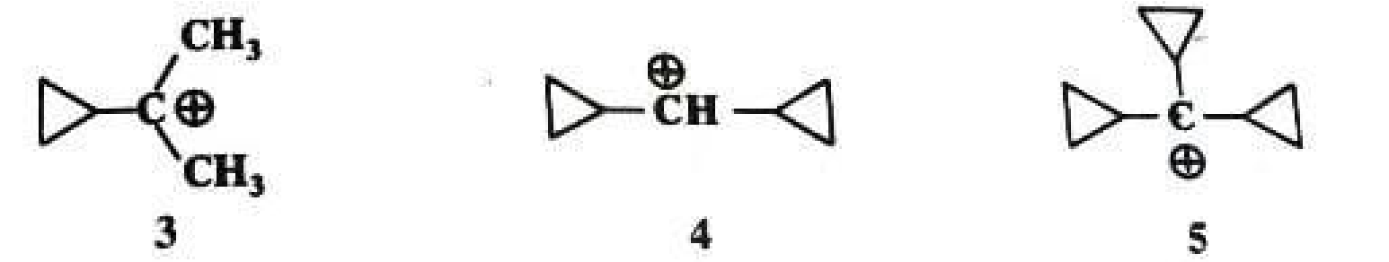
Nmr and other studies have shown that the vacant p orbital lies parallel to the C-2, C-3 bond of the cyclopropane ring and not perpendicular to it. In this respect the geometry is similar to that of a cyclopropane ring conjugated with a double bond.
The stabilizing effect just discussed is unique to cyclopropyl groups. Cyclobutyl and larger cyclic groups are about as effective at stabilizing a carbon as ordinary alkyl groups.
Another structural feature that increases carbocation stability is the presence, adjacent to the cationic centre, of a hetero atom bearing an unshared pair, e.g., oxygen, nitrogen or halogen. Such ions are stabilized by resonance:
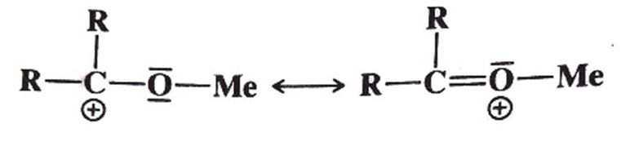
The methoxymethyl cation can be obtained as a stable solid, MeOCH₂⁺ SbF₆⁻. The carbocations containing either a β or Γ silicon atom are also stabilized, relative to similar ions without the silicon atom. Simple acyl cations RCO⁺ have been prepared in solution and the solid state. The acetyl cation CH₃CO⁺ is about as stable as the tertiary butyl cation. The 2,4,6-trimethylbenzoyl and 2,3,4,5,6-pentamethylbenzoyl cations are espetially stable (for steric reason) and are easily formed in 96% H₂SO₄. These ions are stabilized by a canonical form containing a triple bond (G), though the positive charge is principally located on the carbon, so that F contributes more than G.
The stabilities of most other stable carbocations can also be attributed to resonance. Where resonance stability is completely lacking, as in the penyl (C₆H₅⁺ ) or vinyl cations, the ion, if formed at all, is usually very short-lived. Nither vinyl nor phenyl cation has as yet been prepared as a stable species in solution. Various quantitative methods have been developed to express the relative stabilities of carbocations. One of the most common of these, though useful only for relatively stable cations that are formed by ionization of alcohols.
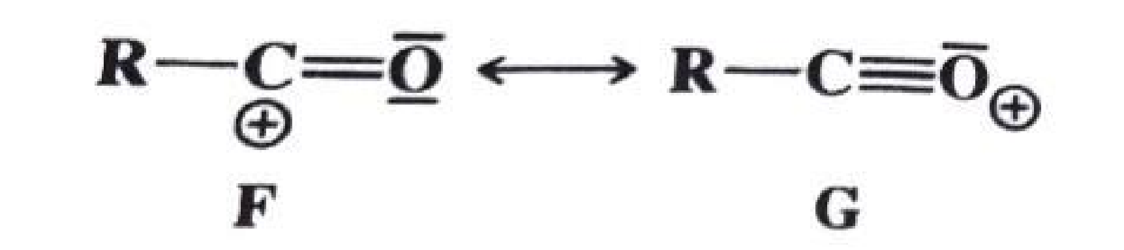
Acidic solutions, is based on the equation pK_{R}+ is the pK value for the reaction R⁺ + 2H₂O ROH + H₃O⁺ and is a measure of the stability of the carbocation.
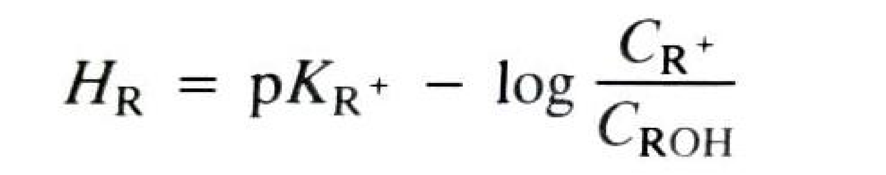
H_{R} is an easily obtainable measurement of the acidity of a solvent and approaches pH at low concentrations of acid. In order to obtain pK_{R}+ for a cation R⁺, one dissolves the alchohol ROH in an acidic solution of known H_{R}. Then the concentrations of R⁺ and ROH are obtained, generally from spectra, and pK_{R}+ is easily calculated.
A measure of carbocation stability that applies to less-stable ions is the dissociation energy D(R^{+___} H⁻) for the cleavage reaction R___H→R⁺ + H⁻, which can be obtained from photoelectron spectroscopy and other measurements.
Some values of D(R^{+___} H⁻) are shown in Table 5.1. Within a given class of ion, e.g. primary, secondary, allylic, aryl, etc., D(R^{+___} H⁻) has been shown to be linear function of logarithm of the number of atoms in R⁺, with larger ions being more stable.
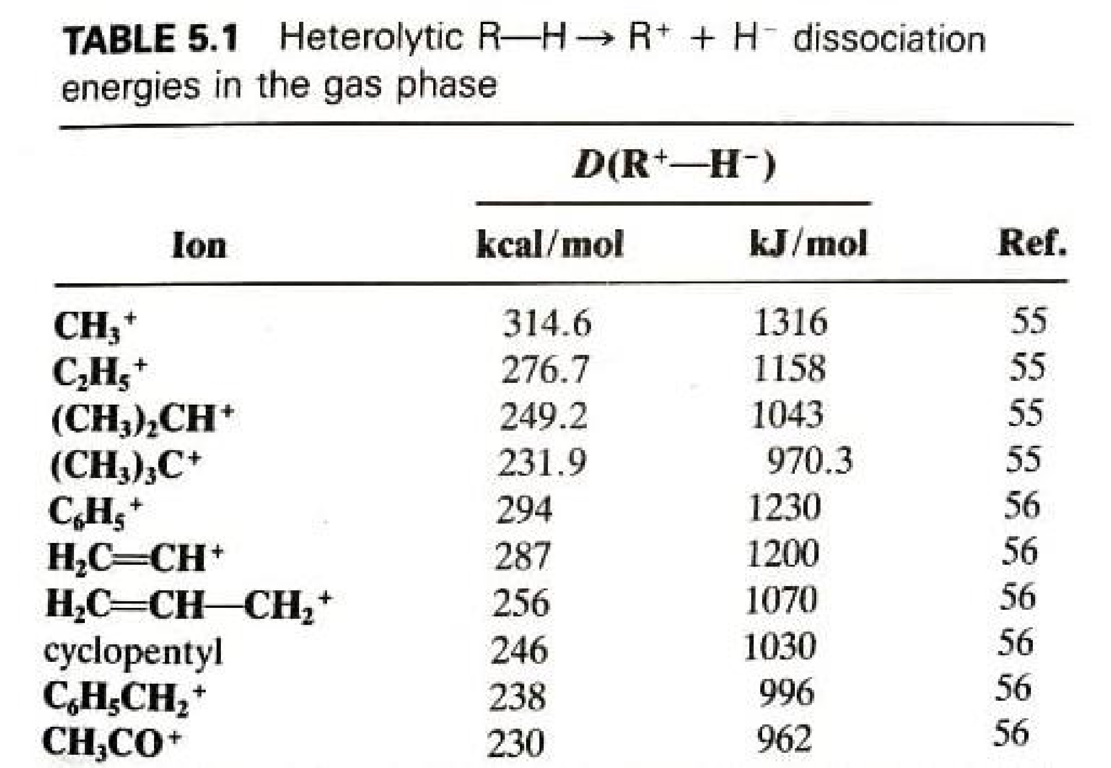
Since the central carbon of tricoordinatedcarbocations has only three bonds and no other valence electron, the bonds are sp² and should be planar. Raman, ir and nmr spectroscopic data on simple alkyl cations show this to be so. Other evidence is that carbocations are difficult or impossible to form at bridgehead atoms in [2.2.1] systems, where they cannot be planar. However, larger bridgehead ions can exist. For example, the adamantyl cation (6) has been synthesized, as the SF₆⁻ salt. Among other bridgehead cations that have been prepared in super acid solution at -78°C are do decahydryl cation (7) and the one 1-trishomobarrelyl cation (8).
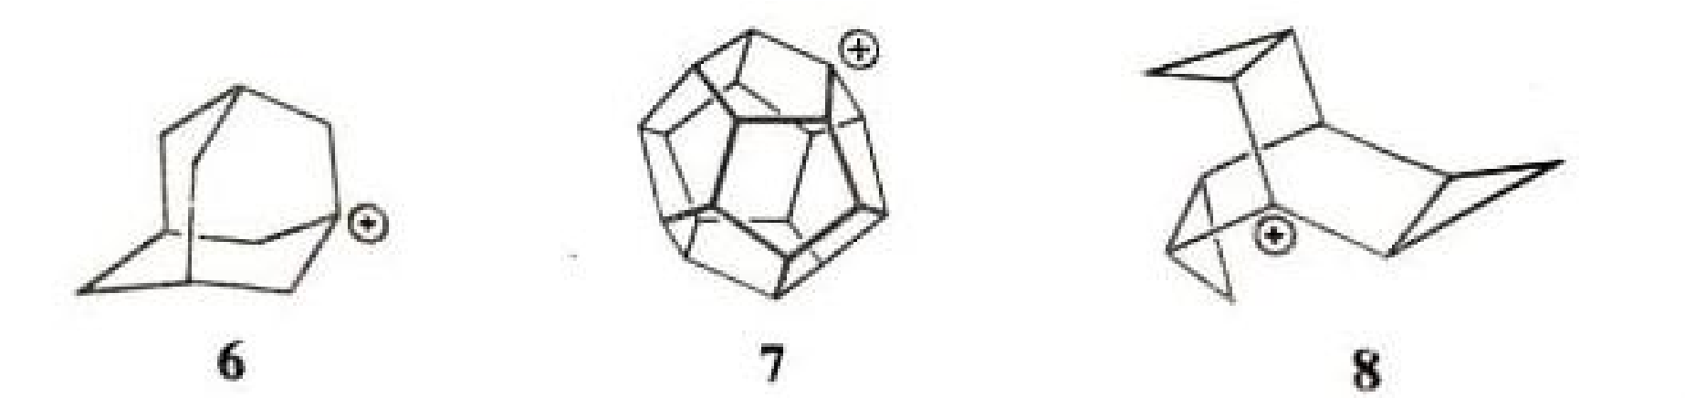
In the latter case, the instability of the bridgehead position is balanced by the extra stability gained from the conjugation with the three cyclopropyl groups.
Triarylmethyl cations are propaller shaped, though the central carbon and the three ring carbons connected to it are in a plane.
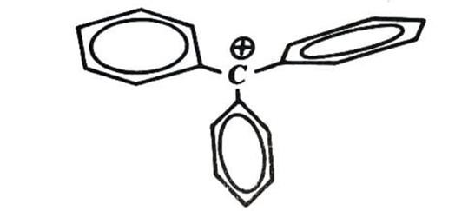
The three benzene rings can not be all in the same plane because of the steric hindrance, though increased resonance energy would be gained if they could.
An important tool for the investigation of carbocation structure is measurement of the C nmr chemical shift of the carbon atom bearing the positive charge. This shift approximately correlates the electron density on the carbon. C chemical shifts for a number of ions. As shown in the table, the substitution of an ethyl for a methyl or a methyl for a hydrogen causes downfield shift, indicating that the central carbon becomes somewhat more positive.
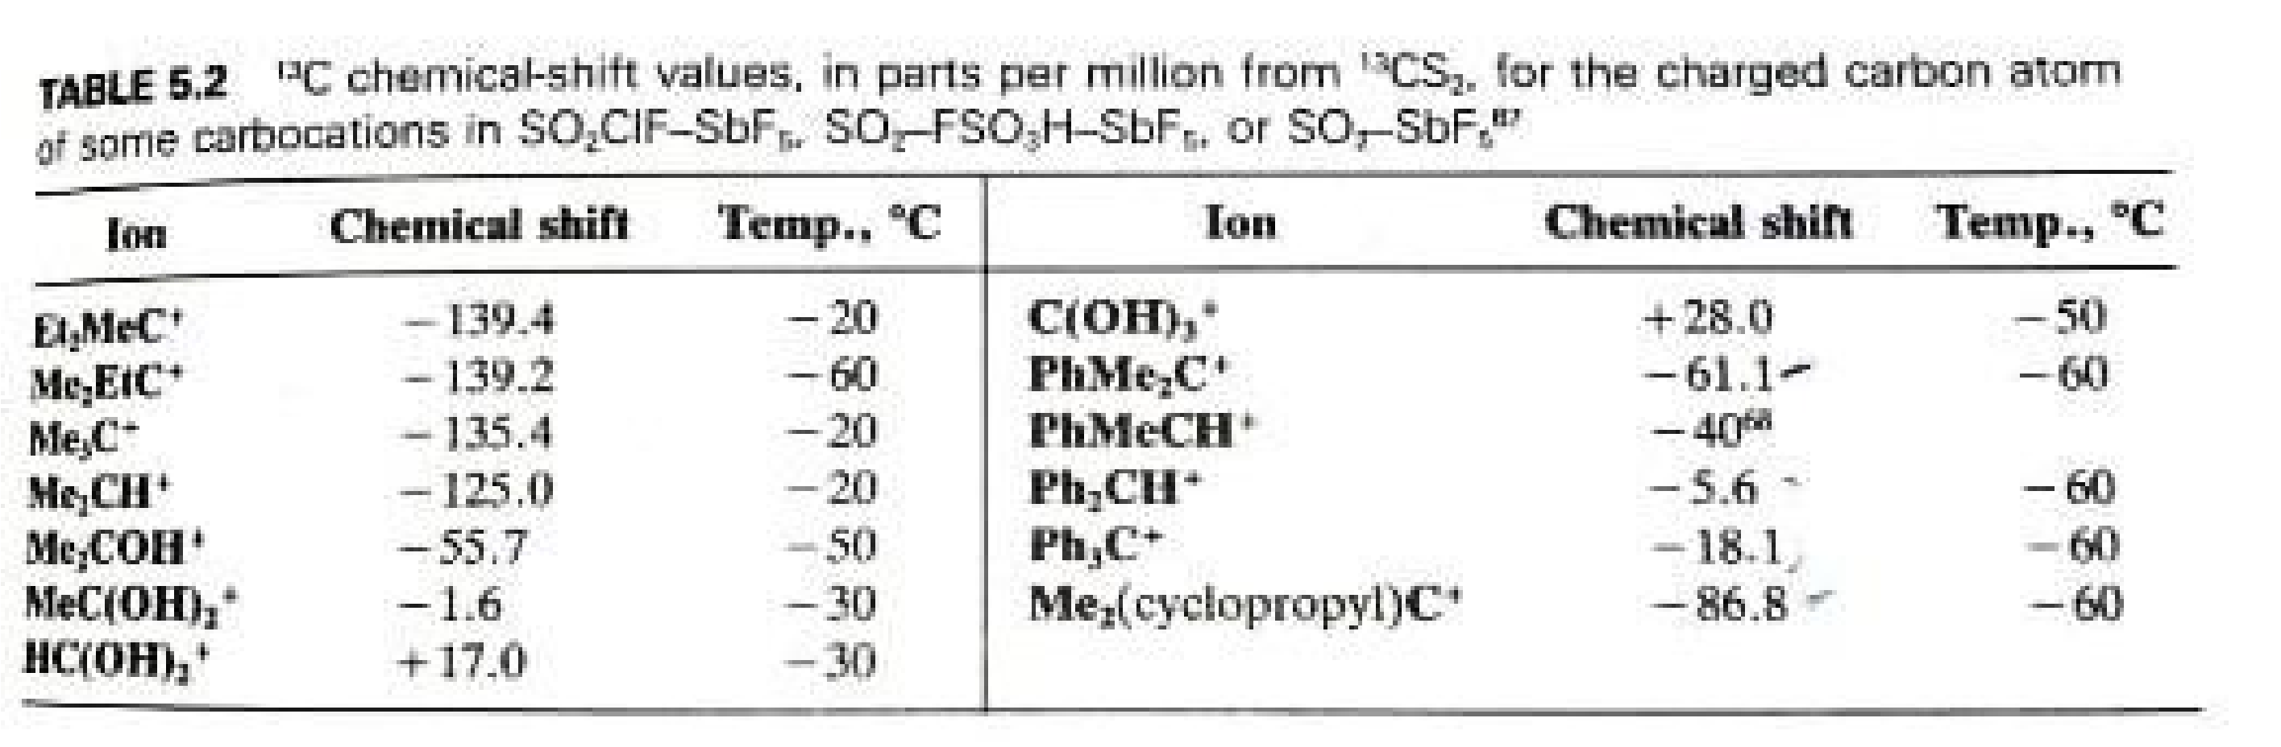
On the other hand, the presence of hydroxyl or phenyl groups decreases positive character of the central carbon. The C chemical shifts are not always in extract order of carbocation stabilities as determined in other ways.
Thus the chemical shift shows that the triphenylmethyl cation has more positive central carbon than diphenylmethyl cation, though the former is more stable.
Also the 2-cyclopropylpropyl and 2-phenylpropyl cations have shifts of -86.8 and -61.1, respectively, though we have seen that according to other criteria a cyclopropyl group is better than a phenyl group at stabilizing a carbocation.
The reasons for this discrepancy are not fully understood.

The Generation and Fate of Carbocations.
Carbocations, stable or unstable, are usually generated in one of two general ways:
- A direct ionization, in which a group attached to a carbon atom leaves with its pair of electrons.
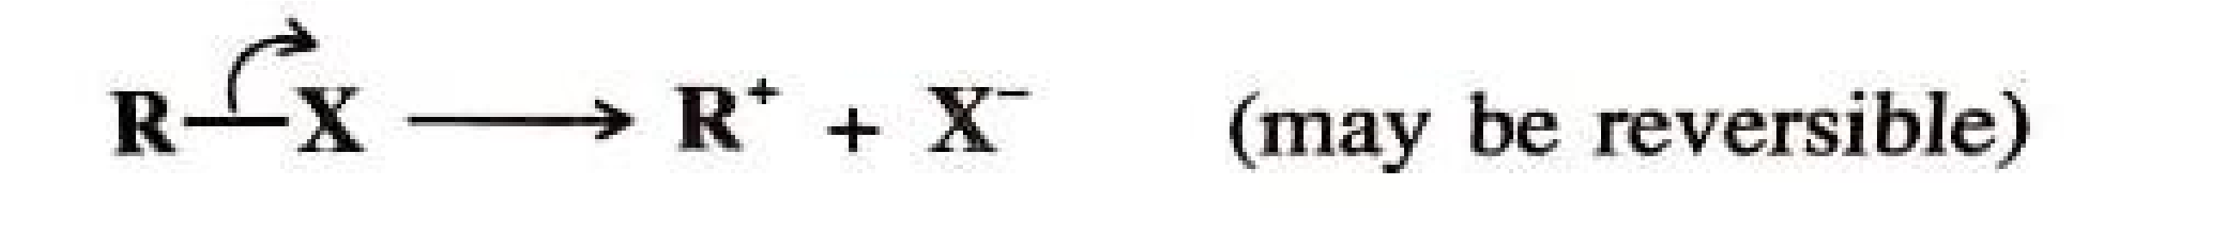
- A proton or other positive species adds to one atom of an unsaturated system, leaving the adjacent carbon atom with a positive charge.
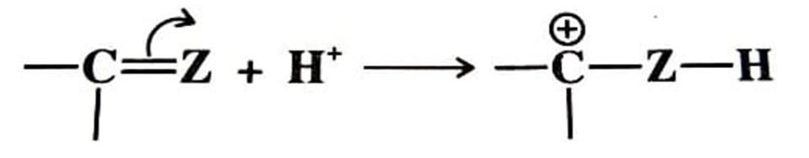
Formed by either process, carbocations are most often short-lived transient species and react further without being isolated.
The two chief pathways by which carbocations react to give stable products are the reverse of the two pathways just described.
  - The carbocation may combine with a species possessing an electron pair.
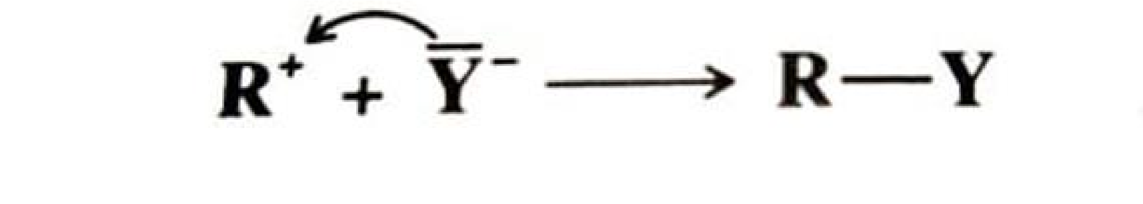
This species may be OH⁻, halide ion, or any other negative ion, or it may be neutral species with a pair to donate, in which case, of course, the immediate product must bear positive charge.
  - The carbocation may lose a proton (or much less often, another positive the ion) from adjacent atom. 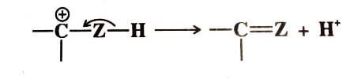
Carbocations can also adopt two other pathways that lead not to stable other carbocations products, but to other carbocation.
- Rearrangement: An alkyl or aryl group or a hydrogen (sometimes another group) migrates with its electron pair to the positive center, leaving another positive charge behind.
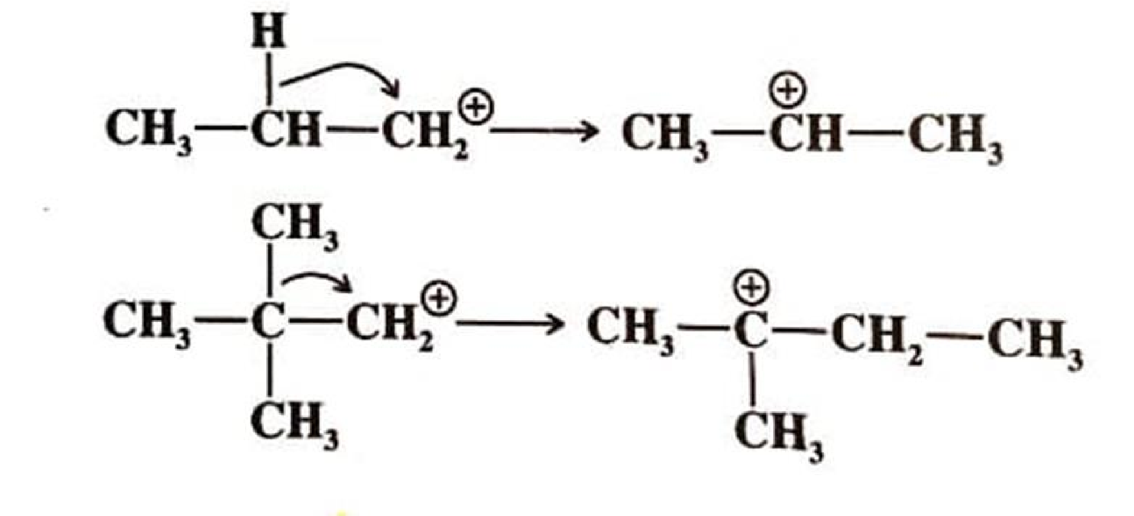
- Addition: A carbocation may add to a double bond, generating a positive charge ar a new position.
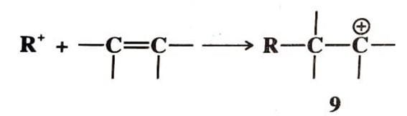
Whether formed by pathway 3 or 4, the new carbocation normally reacts further in an effort to stabilize itself, usually by pathway 1 or 2. However, 9 can add to another alkene molecule, and this product can add to still another, etc. This is one of the mechanisms vinyl polymerization.
____________________________

Problems on Classical Carbocations.
- Arrange the following carbocations in the order of increasing stability.
  - Benzyl > 30 > 20 > 10
  - Benzyl > 10 > 20 > 30
  - 30 > 20 > 10 > Benzyl
  - 10 > 20 > 30 > Benzyl
- Positive charge of carbocations can be dispersed by ____
  - (+I) effect of alkyl group
  - Resonance in allyl or benzyl carbocation
  - Hyperconjugation in 10, 20 and 30 carbocations
  - All of the mentioned
- The homolytic bond dissociation energy is inversely proportional to the ____
- Bond length
- Ease of formation
- Dipole moment
- All of the mentioned
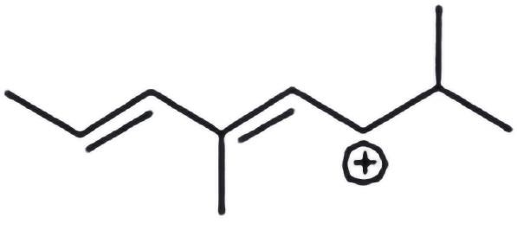
4 . Which carbocation is the most stable?
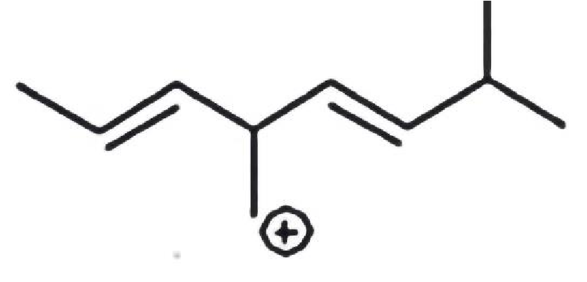
a) b)

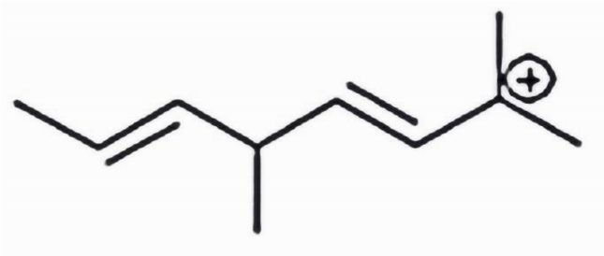
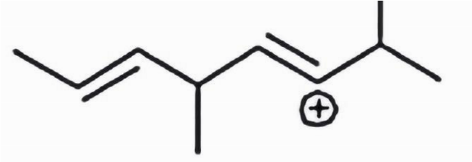
c) d)

5. Which one among the following carbocations has the longest half-life?
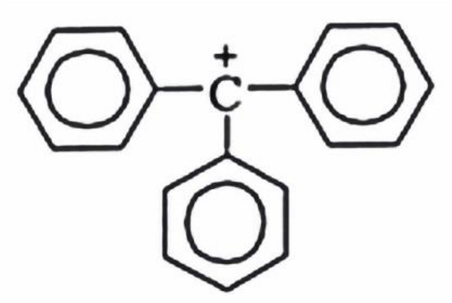
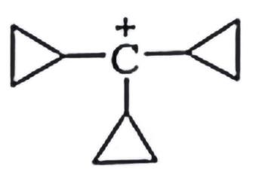
a) b)

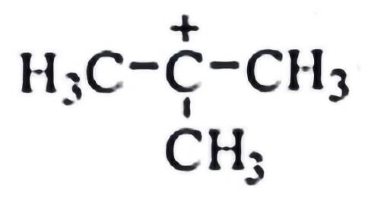
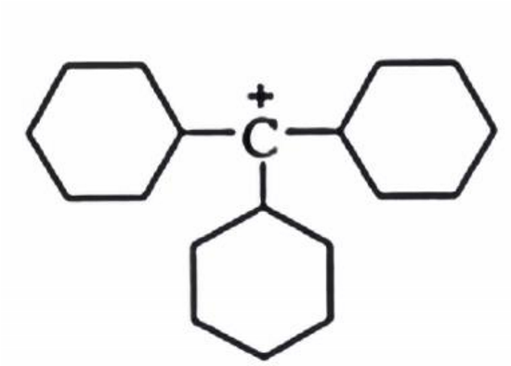
c) d)
6. The order of decreasing stability of the following cations is?
(I) CH₃C⁺HCH₃ (II) CH₃C⁺HOCH₃ (III) CH₃C⁺ HCOCH₃
a) III > II > I b) I > II > III
c) II > I > III d) I > III > II
7 . Which intermediate is involved in the reaction given below?
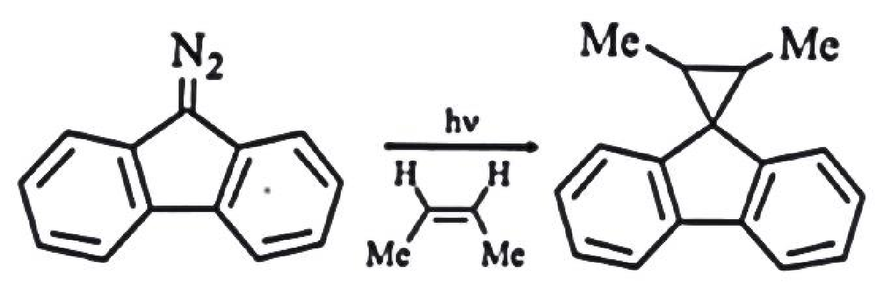
a) free radical b) carbocation
c) carbanion d) carbene
Answers of these problems:
1-a 2-d 3-b 4-b 5-a 6-a 7-d
__________________________

