ASSIGNMENT
Pericyclic Reactions
MCQ:
1. The electrocyclic reaction for ground state of hexatrienes:
- conrotatory
- disrotatory
- conrotatory or disrotatory depending on the temperature at which reaction is carried out
- Cannot be predicted
2. The thermal ring opening reactions of cyclobutenes are:
- conrotatory
- disrotatory
- conrotatory or disrotatory depending on the temperature at which reaction is carried
- Cannot be predicted

3. Claisen rearrangement is an example of
  - [2, 3] sigmatropic rearrangement
  - [2, 4] sigmatropic rearrangement
  - [1, 5] sigmatropic rearrangement
  - [3, 3] sigmatropic rearrangement
4. In a cycloaddition reaction, if both the bonds to a component are
formed on the same face, the process is termed as :
- suprafacial
- antarafacial
- suprafacial-suprafacial
- antarafacial-antarafacial

5. In the reaction of cyclopentadiene with acrylate giving Diels-Alder reaction products, the interacting frontier orbitals are ester
- HOMO of a diene and LUMO of a dienophile
- HOMO of a dienophile and LUMO of a diene
- HOMO of a diene and HOMO of a dienophile
- LUMO of a diene and LUMO of a dienophile
6. In sigmatropic thermal expansion of 1,1-dicyclopropyl ethene, the final product:
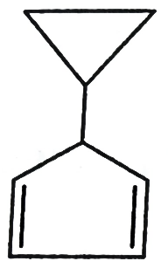
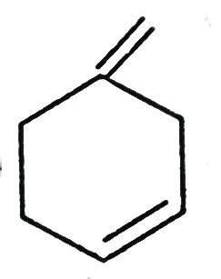
- b)

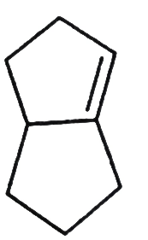
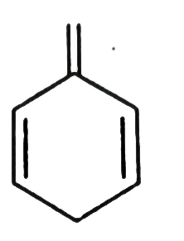
c) d)

7. Diels-alder reaction is a
a) [2 + 2] thermal cyclization
b) [4 + 2] photoaddition
c) [4 + 2] cycloaddition
d) [3 + 3] cycloaddition
8. Diels-alder reaction normally yields endo-adduct as a major product. This is due to
a) higher stability of the product
b) faster rate of formation of the endo product
c) steric hindrance
d) secondary orbital interactions between a diene and a dienophile

9. The LUMO of the ground state buta-1, 3-diene is
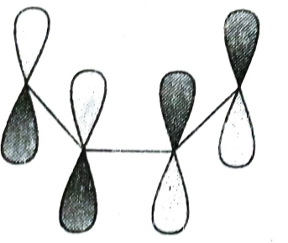
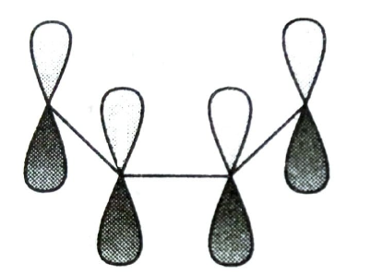
a) b)

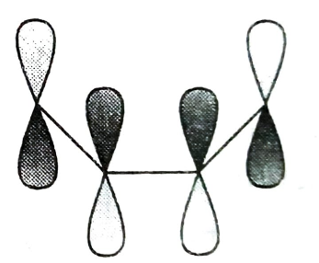
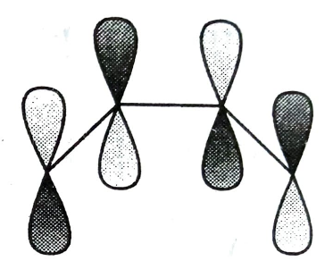
c) d)

10. Cope rearrangement is
a) [2, 3] sigmatropic rearrangement
b) [3, 2] sigmatropic rearrangement
c) [3, 3] sigmatropic rearrangement
d) [1, 3] sigmatropic rearrangement

Answers:
1-b, 2-a, 3-d, 4-c, 5-a, 6-d, 7-c, 8-d, 9-d, 10-c
_______________________
*For discussion please mail me or call me*
anweshabhattajaipuria@gmail.com
9474460926

